
Faculty of Computer and Informatics Engineering
Department of Communications and
Networks Engineering

Design of a Wireless Black Box for Cars
تصميم صندوق أسود لاسلكي للسيارات

Prepared by
Mohammad Lutfi Qassar

Supervised by
Prof. Dr. Eng. Hassan Ahmad
Eng. Mohammad Othman

Supervisor’s Declaration
I hereby certify that the preparation of this project, entitled “Design of a Wireless Black Box for Cars”, was carried out by the student Mohammad Lutfi Qassar under my supervision in the Department of Communications and Networks Engineering, Faculty of Computer and Informatics Engineering, and that it fulfils part of the requirements for the Bachelor’s degree in Communications and Networks Engineering.
Academic Rank: ………………………………
Name: ……………………………………
Signature: ………………………………
Date: …………………………………

Abstract
This project presents the design and implementation of a smart wireless black box system for vehicles based on the ESP32 microcontroller. The system is designed to monitor, record, and analyse important vehicle data during normal driving conditions and traffic accidents in order to improve road safety and support accident investigation processes with accurate and reliable information.
The ESP32 microcontroller acts as the main control and processing unit responsible for collecting, organizing, and storing data from multiple sensors and modules integrated into the system. Vehicle motion and orientation are monitored using the MPU6050 inertial measurement unit, which combines an accelerometer and gyroscope to detect acceleration, sudden movement, vibration, and abnormal driving behavior. A DS1302 Real-Time Clock (RTC) module is also integrated to provide accurate timestamps for all recorded events and measurements.
To provide visual evidence during vehicle operation, the system uses an ESP32-CAM module that continuously records video and stores it on an SD memory card in segmented AVI format. This feature helps document road conditions and surrounding events before and during accidents.
The system is further enhanced using a SIM808 module that combines GPS positioning and GSM/GPRS communication. This enables real-time vehicle tracking and allows emergency alerts containing the vehicle location to be transmitted automatically when critical events occur. Additional sensors include the MQ-3 alcohol sensor for detecting ethanol concentration, the SW-420 vibration sensor for impact detection, and LM35 temperature sensors for monitoring thermal conditions in different parts of the vehicle.
All collected data, including motion measurements, GPS coordinates, timestamps, temperature readings, vibration events, alcohol detection data, and video recordings, are securely stored on the SD card for later retrieval and analysis. The system operates automatically once powered on and provides a practical, low-cost, and efficient solution for vehicle monitoring, accident recording, and intelligent transportation safety applications.

الملخص
يقدم هذا المشروع تصميم وتنفيذ نظام صندوق أسود ذكي ولاسلكي للمركبات بالاعتماد على المتحكم الدقيق ESP32. يهدف النظام إلى مراقبة وتسجيل وتحليل البيانات المهمة الخاصة بالمركبة أثناء ظروف القيادة العادية وحوادث السير، وذلك بهدف تحسين السلامة المرورية ودعم عمليات التحقيق في الحوادث من خلال توفير معلومات دقيقة وموثوقة.
يعمل المتحكم ESP32 كوحدة التحكم والمعالجة الرئيسية المسؤولة عن جمع البيانات وتنظيمها وتخزينها من عدة حساسات ووحدات مدمجة ضمن النظام. تتم مراقبة حركة المركبة واتجاهها باستخدام وحدة القياس العطالية MPU6050، التي تجمع بين مقياس التسارع والجيروسكوب للكشف عن التسارع والحركات المفاجئة والاهتزازات وسلوك القيادة غير الطبيعي. كما تم دمج وحدة الساعة الحقيقية DS1302 لتوفير طابع زمني دقيق لجميع الأحداث والقياسات المسجلة.
ولتوفير توثيق مرئي أثناء تشغيل المركبة، يستخدم النظام وحدة ESP32-CAM التي تقوم بتسجيل فيديو بشكل مستمر وتخزينه على بطاقة ذاكرة SD بصيغة AVI مجزأة، مما يساعد في توثيق ظروف الطريق والأحداث المحيطة قبل الحوادث وأثناء وقوعها.
كما تم تعزيز النظام باستخدام وحدة SIM808 التي تجمع بين خدمات تحديد الموقع GPS وتقنيات الاتصال GSM/GPRS، مما يتيح تتبع موقع المركبة بشكل لحظي وإرسال تنبيهات طارئة تتضمن موقع المركبة تلقائيًا عند حدوث أحداث حرجة. بالإضافة إلى ذلك، يتضمن النظام حساس MQ-3 للكشف عن تركيز الكحول، وحساس الاهتزاز SW-420 لاكتشاف الصدمات، وحساسات LM35 لمراقبة درجات الحرارة في أجزاء مختلفة من المركبة.
يتم تخزين جميع البيانات المجمعة، بما في ذلك بيانات الحركة وإحداثيات الموقع والطوابع الزمنية ودرجات الحرارة وبيانات الاهتزاز والكشف عن الكحول وتسجيلات الفيديو، بشكل آمن على بطاقة الذاكرة لاسترجاعها وتحليلها لاحقًا. يعمل النظام تلقائيًا بمجرد تشغيله، ويقدم حلاً عمليًا منخفض التكلفة وفعالًا لمراقبة المركبات وتسجيل الحوادث وتطبيقات السلامة الذكية في أنظمة النقل الحديثة.

List of Contents
Supervisor’s Declaration 2
Abstract 3
List of Figure 8
List of Table 9
List of Abbreviations 10
Chapter 1 General Theoretical Foundations 13
1.1 Introduction 13
1.2 Historical Background 13
1.3 Problem Statement 14
1.4 Significance of the Project 14
1.5 Objectives 15
1.5.1 Recording Motion Data 15
1.5.2 Video Recording 15
1.5.3 Time Stamping 15
1.5.4 Location Tracking 15
1.5.5 Driver-Safety Monitoring 15
1.5.6 Thermal Monitoring 16
1.5.7 Real-Time Remote Alerts 16
1.6 Scope of Work 16
1.7 Conclusion of Chapter One 16
Chapter 2 Specific Theoretical Background 17
2.1 Introduction 17
2.2 The Black Box for Cars 17
2.3 The ESP32 Microcontroller 17
2.3.1 Architecture and Features 18
2.3.2 Role of the ESP32 in the Project 19
2.4 MPU6050 Motion Sensor 19
2.5 DS1302 RTC Module 21
2.6 ESP32-CAM Module 21
2.6.1 AVI File Structure 22
2.7 SIM808 GSM/GPS Module 23
2.8 MQ-3 Alcohol Sensor 24
2.9 SW-420 (801s) Vibration Sensor 25
2.10 L298N Dual H-Bridge Motor Driver 26
2.11 LM35 Temperature Sensor 27
2.12 Communication Protocols 28
2.12.1 I²C (Inter-Integrated Circuit) 28
2.12.2 UART (Universal Asynchronous Receiver/Transmitter) 29
2.12.3 SPI / SD_MMC 29
2.12.4 GPIO and Interrupts 29
2.13 Conclusion of Chapter Two 30
Chapter 3 Practical Implementation 31
3.1 Introduction 31
3.2 Main Project Components 31
3.2.1 ESP32 Main Controller 31
3.2.2 ESP32-CAM Recorder 31
3.2.3 MPU6050 Motion Sensor 31
3.2.4 DS1302 RTC Module 31
3.2.5 SD Memory Card 31
3.2.6 SIM808 GSM/GPS Module 31
3.2.7 MQ-3 Alcohol Sensor 31
3.2.8 SW-420 Vibration Sensor 31
3.2.9 L298N Motor Driver and DC Motors 32
3.2.10 LM35 Temperature Sensors 32
3.3 Comparison between ESP32, Arduino and Raspberry Pi 32
3.4 Pin Assignment Tables 33
3.5 Power Distribution 34
3.6 System Operating Mechanism 35
3.7 Block Diagram 36
3.8 Conclusion of Chapter Three 37
Chapter 4 Results and Discussion 38
4.1 Introduction 38
4.2 System Flowchart 38
4.3 Practical Wiring of the Project 38
4.4 Runtime Operating Mechanism 38
4.5 ESP32 Main-Controller Code 39
4.5.1 Headers, Pin Definitions and Global State 39
4.5.2 Motor Control and Vibration ISR 40
4.5.3 MPU6050 Initialisation, Reading and Calibration 41
4.5.4 RTC, Analogue Sensors and GPS Decoding 42
4.5.5 Telemetry Frame, setup() and loop() 44
4.6 ESP32-CAM Video-Recorder Code 46
4.6.1 Constants, Pin Mapping and Global State 46
4.6.2 Low-Level Write Helpers, SD and Camera Initialisation 48
4.6.3 AVI Header, Segment Lifecycle and Frame Writer 49
4.6.4 Recording Control, Telemetry Handling, setup() and loop() 52
4.7 Equations Used in the Project 54
4.7.1 ADC Conversion 54
4.7.2 LM35 Temperature 54
4.7.3 Accelerometer Scaling 54
4.7.4 Motion Classification 54
4.7.5 Frame Period 55
4.7.6 Maximum Frames per Segment 55
4.7.7 AVI Index Size 55
4.7.8 Average Bit Rate of the Recorder 55
4.7.9 Storage Budget 55
4.7.10 Telemetry Bandwidth 55
4.8 Practical Results 55
4.9 Conclusion of Chapter Four 57
Chapter 5 Difficulties, Future Prospects, and Proposed Development Ideas 58
5.1 Introduction 58
5.2 Difficulties Encountered During Implementation 58
5.2.1 Technical Difficulties in Connecting the Components 58
5.2.2 Programming Difficulties 58
5.2.3 System Stability During Long Operation 58
5.2.4 Managing Storage on the Memory Card 58
5.3 Future Prospects of the Project 59
5.4 Proposed Development Ideas 59
5.4.1 Cloud Upload of Event Windows 59
5.4.2 Intelligent Event Classification 59
5.4.3 Additional Sensors 59
5.4.4 Driver-Facing User Interface 59
5.4.5 Hardware Hardening 59
5.5 Conclusion of Chapter Five 60
Conclusions 61
Recommendations 62
References 63

List of Figure
Figure ‎0—1Evolution of black box technology from aviation to automotive 14
Figure ‎0—1ESP32 DevKit C development board 17
Figure ‎0—2ESP32 dual-core block diagram 18
Figure ‎0—3 ESP32 internal memory map 19
Figure ‎0—4MPU6050 (GY-521) IMU module 20
Figure ‎0—5 DS1302 RTC module 21
Figure ‎0—6AI-Thinker ESP32-CAM module 22
Figure ‎0—7 Simplified AVI container layout 23
Figure ‎0—8 SIM808 GSM/GPS module 23
Figure ‎0—9 MQ-3 alcohol sensor module 24
Figure ‎0—10 SW-420 (801s) vibration sensor module 25
Figure ‎0—11 L298N dual H-bridge motor driver 26
Figure ‎0—12 LM35 analogue temperature sensor 27
Figure ‎0—13 I²C bus topology 28
Figure ‎0—14 I²C transaction timing (START, 7-bit address, R/W, ACK, data byte, ACK, STOP) 29
Figure ‎0—1 Power-distribution tree from the 12 V vehicle rail to the individual modules 35
Figure ‎0—2 Block diagram of the wireless black box system 36
Figure ‎0—1 Data-flow block diagram of the integrated system 38
Figure ‎0—2 39

List of Table
Table 1 Comparison of common ESP32 board variants 18
Table 2Comparison of common IMU devices 20
Table 3 Comparison of common RTC modules 21
Table 4ESP32-CAM image-sensor frame sizes (OV2640) 22
Table 5 Comparison of common GNSS / cellular modules 24
Table 6 Comparison of common gas-sensor families 25
Table 7Comparison of common vibration / shock sensors 26
Table 8 Comparison of common motor-driver ICs 27
Table 9 Comparison of common analogue temperature sensors 28
Table 10 Comparison of embedded serial protocols 29
Table 11 Comparison between ESP32, Arduino UNO and Raspberry Pi 32
Table 12 Main controller pin assignment 33
Table 13ESP32-CAM pin assignment 34
Table 14 Power-budget estimate of the system 34
Table 15 Summary of practical test results 56
Table 16 Storage budget per recording hour 56

List of Abbreviations
Abbreviation | Meaning
ADC | Analogue-to-Digital Converter
API | Application Programming Interface
AT | Attention (modem command prefix)
AVI | Audio Video Interleave (RIFF container)
Bluetooth | Short-range wireless communication technology
CCTV | Closed-Circuit Television
CGNSINF | SIM808 GNSS information AT response
CSV | Comma-Separated Values
DAC | Digital-to-Analogue Converter
DMA | Direct Memory Access
DS1302 | Maxim/Dallas Real-Time Clock IC
EDR | Event Data Recorder
ESP32 | 32-bit microcontroller from Espressif Systems
ESP32-CAM | ESP32 module with built-in OV2640 camera
FCC | Federal Communications Commission
FPS | Frames Per Second
FRAMESIZE_VGA | Camera resolution constant (640 × 480 px)
GNSS | Global Navigation Satellite System
GPIO | General-Purpose Input / Output
GPRS | General Packet Radio Service
GPS | Global Positioning System
GSM | Global System for Mobile Communications
HTTP | HyperText Transfer Protocol
HSPI / VSPI | ESP32 hardware SPI controllers
I²C | Inter-Integrated Circuit serial bus
IMU | Inertial Measurement Unit
IoT | Internet of Things
IRAM_ATTR | ESP32 attribute placing code in internal RAM
ISR | Interrupt Service Routine
JPEG / MJPEG | Joint Photographic Experts Group / Motion JPEG
L298N | Dual H-bridge DC-motor driver IC
LDO | Low-Dropout linear voltage regulator
LiPo | Lithium Polymer rechargeable battery
LM35 | Analogue precision Celsius temperature sensor
LSB | Least Significant Bit
MEMS | Micro-Electro-Mechanical System
MPU | Motion Processing Unit
MQ-3 | Tin-dioxide ethanol gas sensor
NMEA | ***National Marine Electronics Association sentence format
OV2640 | 2 MP CMOS image sensor used in the ESP32-CAM
PCB | Printed Circuit Board
PWM | Pulse-Width Modulation
RAM | Random-Access Memory
RIFF | Resource Interchange File Format
RPM | Revolutions Per Minute
RTC | Real-Time Clock module
RX / TX | Receive / Transmit (UART signals)
SCCB | Serial Camera Control Bus (Omnivision)
SD | Secure Digital memory card
SD_MMC | SD-Multi-Media-Card interface mode
SIM808 | SIMCom integrated GSM/GPRS/GNSS module
SMS | Short Message Service
SnO₂ | Tin Dioxide (MQ-3 sensing element)
SPI | Serial Peripheral Interface
SW-420 | Spring-based shock / vibration sensor
UART | Universal Asynchronous Receiver/Transmitter
USB | Universal Serial Bus
UTC | Coordinated Universal Time
VGA | Video Graphics Array (640 × 480 resolution)
Wi-Fi | Wireless local-area network standard

Chapter 1
General Theoretical Foundations

1.1 Introduction
In the current age of technology, the world faces growing challenges in road safety, and vehicle accidents remain among the most destructive events that societies have to confront. According to figures published by the World Health Organization, road traffic injuries are responsible for an estimated 1.19 million deaths each year and rank among the leading causes of death for children and young adults aged 5 to 29. Beyond the human cost, road crashes also impose a heavy economic burden, with most countries losing around three per cent of their gross domestic product. Reducing this toll therefore requires action on several fronts at once: safer roads, safer vehicles, safer behavior, and — equally important — better evidence on which to base interventions when accidents do occur.
One of the main tools capable of contributing to safer roads is the “black box” system installed in vehicles. Traditional black box systems relied on wired connections to the vehicle bus and required physical extraction of the storage medium in order to retrieve the recorded data. Advances in low-cost wireless technology now offer the opportunity to develop a more efficient and versatile solution, one that records data continuously, indexes it against the geographic position of the vehicle, and is able to push real-time alerts to a remote party as soon as a safety-critical event occurs.
The wireless car black box is a technology poised to bring about a qualitative shift in the automotive industry’s approach to safety, data collection, and vehicle management. This advanced system integrates wireless communication capabilities into the traditional functions of the black box, providing real-time data transmission and analysis. By leveraging wireless communication, the wireless black box improves vehicle monitoring, diagnostics, and accident reconstruction, paving the way for safer roads and more efficient vehicle management. In this chapter we introduce the field, situate the project within it, define the problem that the design seeks to solve, and lay out the objectives and scope of the work.

1.2 Historical Background
The concept of black-box recording originated in the aviation industry in the mid-twentieth century. The earliest devices, developed in the 1950s, recorded a small set of flight parameters and the pilots’ voices onto magnetic wire, with the aim of providing investigators with a factual basis on which to determine the causes of accidents. By the 1960s the use of Flight Data Recorders and Cockpit Voice Recorders had become mandatory on commercial aircraft in most jurisdictions, and the design of these devices evolved to withstand impact, fire and water immersion. The distinctive bright-orange enclosure that is so closely associated with the term “black box” is in fact a design feature meant to make the recorder easier to locate at a crash site.
The adoption of comparable devices in automobiles followed a different trajectory. The first generation of automotive black boxes appeared in the late 1990s, integrated into the airbag control modules of high-end vehicles. These units stored a few seconds of data in non-volatile memory immediately before, during, and after an impact — vehicle speed, engine RPM, brake state, throttle position, and the deceleration profile recorded by the airbag accelerometers. From 2014 onwards, regulators in the United States required this functionality on most new light vehicles under the heading of Event Data Recorder (EDR), and similar regulations have since spread to other markets. Modern factory-fitted EDRs, however, still record only a brief window around a triggering event, store the data locally, and are read out manually with proprietary tooling.
Figure 1.1 summarises this evolution from the early aviation recorders to the current generation of wireless, sensor-fused automotive systems.
1950s Flight Data Recorder (wire) 1990s Airbag-module EDR snapshot 2010s Continuous in-car logging Today Wireless, sensor-fused

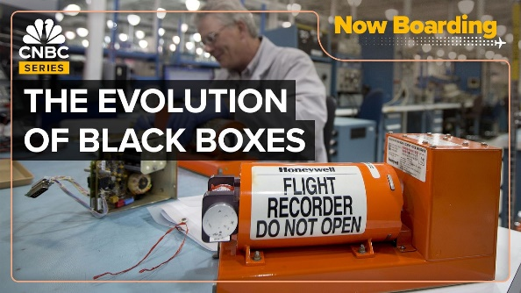
Figure ‎0—1Evolution of black box technology from aviation to automotive
The wireless car black box being designed in this project sits at the right-hand end of that timeline. It records a continuous stream of motion, location, environmental and video data; segments the video into manageable thirty-second files; tags every entry with the real time and the GPS coordinates; and is able to raise a remote alert over the cellular network within seconds of a critical event.

1.3 Problem Statement
Despite the significant progress in vehicle safety technologies in recent years, traffic accidents still represent a major challenge worldwide. Identifying the causes of these accidents and working to reduce them is an essential step toward improving road safety. Among the technologies supporting this effort are vehicle black box systems, which record critical data related to the state of the vehicle before, during, and after an accident.
Most factory-fitted systems of this kind have three important limitations. First, they record only a very short window of data around a triggering event, so they are of little help when an investigator needs to understand how the driver was operating the vehicle over the minutes or hours before the impact. Second, they store the data locally and require physical access to the vehicle in order to retrieve it; in the case of a fire, theft, or destruction of the cabin electronics, the data is lost. Third, they are closed, proprietary systems — the data formats are not standardised, the tools needed to read them are restricted, and the data they capture is dictated by the manufacturer rather than by the investigator’s needs.
Advances in wireless communication technologies, in low-cost embedded microcontrollers, and in MEMS sensors have made it possible to design a more sophisticated and flexible alternative. The main challenge addressed by this project is therefore: how can a continuous, multi-sensor automotive event recorder be built from low-cost off-the-shelf components, with on-board video, GPS-tagged motion data, in-cabin safety monitoring, and real-time wireless alerts — while remaining simple enough to integrate into existing vehicles and to be retrieved and analysed without proprietary tooling?

1.4 Significance of the Project
The proposed system has practical significance for several stakeholder groups. For drivers and vehicle owners, it provides a record that can support the user’s account of events in the case of a dispute, and a real-time alert mechanism that can summon help even when the driver is unable to do so. For fleet operators, it provides a continuous, time- and position-stamped record of vehicle and driver behavior that can be used to improve scheduling, fuel use and driver training. For insurance companies, it provides an objective evidence base that reduces the cost of claim assessment and helps detect fraudulent claims. For authorities and accident investigators, the recorded video, motion trace and GPS track make it possible to reconstruct an incident in much more detail than the EDR snapshot stored by the airbag module.
From an educational and engineering perspective, the project is also significant as a worked example of a small but non-trivial embedded system. It exercises a wide range of techniques that occur in many other applications: I²C and UART communication, hardware interrupts, ADC sampling, real-time clock keeping, file-system management on an SD card, on-the-fly construction of a binary container format, AT-command driven cellular communication, and the coordination of two cooperating microcontrollers over a serial link.

1.5 Objectives
The scope of the wireless vehicle black box project is based on a set of requirements and objectives defined in advance according to the nature of the project. In general, this project aims to achieve a number of core goals, summarized below.

1.5.1 Recording Motion Data
Collecting motion data is a fundamental element of the project, given its important role in analyzing the vehicle’s performance and behavior while driving. The system continuously records motion data during vehicle operation — including longitudinal and lateral acceleration, tilt along the three axes, and the discrete impact events detected by the dedicated vibration sensor — providing an accurate picture of the dynamic state of the vehicle on the road.

1.5.2 Video Recording
The system relies on the ESP32-CAM module to capture and record continuous video clips while the vehicle is in operation. The video is encoded as Motion-JPEG inside a custom-built AVI container and is automatically split into thirty-second segments to keep file sizes manageable, ease retrieval and minimize data loss in the event of a sudden power cut. This visual recording provides direct documentation of the driving events and the surrounding road, enhancing the reliability of the recorded data.

1.5.3 Time Stamping
All collected data — whether motion data or video recordings — is linked to real time through the DS1302 RTC module. This module makes it possible to track the sequence of events with high accuracy and to determine the actual time of each reading or recording, even across power cycles thanks to the backup coin cell on the RTC board.

1.5.4 Location Tracking
The system records the geographic location of the vehicle at every moment using the GPS receiver integrated in the SIM808 module. Each telemetry packet is therefore tied not only to a precise timestamp but also to a latitude/longitude/altitude triple together with the ground speed reported by the GNSS section of the module.

1.5.5 Driver-Safety Monitoring
The system actively monitors two safety-critical conditions inside the cabin. An MQ-3 alcohol sensor measures the concentration of ethanol vapor in the cabin air and raises an alert when the reading exceeds a configured threshold, providing a deterrent against driving under the influence. An SW-420 (801s) vibration sensor continuously watches for sudden mechanical shocks and, on detecting an impact, triggers an event tag in the recorded data stream via a hardware interrupt, so that collisions can be located in the log without having to scan the full motion trace.

1.5.6 Thermal Monitoring
Four LM35 analogue temperature sensors are sampled at the same rate as the main telemetry frame, allowing the system to monitor critical thermal points such as the motor bearings, the battery enclosure and the cabin air. Sustained high readings can be used to flag overheating before it becomes a failure.

1.5.7 Real-Time Remote Alerts
When a critical event is detected — a high-impact vibration, an alcohol reading above the limit, or an over-speed condition — the system composes a short message containing the event type, the RTC timestamp and the current GPS coordinates and transmits it over the SIM808’s GSM/GPRS channel. This brings the black box from a purely passive recorder closer to an active safety system, capable of notifying family members, fleet operators, or emergency services within seconds of an incident.

1.6 Scope of Work
The scope of the project as delivered in this report covers (i) the selection and integration of the hardware components listed above; (ii) the development of firmware for two cooperating ESP32 microcontrollers — one acting as the main controller and one as the camera recorder; (iii) the design of a binary AVI writer that runs on the ESP32-CAM and produces files playable on any standard media player; (iv) the design of a CSV-like telemetry format sent from the main controller to the camera and logged together with the video clips on the SD card; and (v) the validation of the integrated system on a small wheeled chassis that emulates the dynamics of a real vehicle. Items that fall outside the scope of this iteration of the project but that are highlighted as future work include over-the-air firmware update, secure cloud upload of event windows, integration with vehicle CAN data, and a smartphone application for live monitoring.

1.7 Conclusion of Chapter One
This chapter has presented the concept of the wireless vehicle black box project and highlighted the role such systems can play in enhancing road safety and assisting in accident documentation. It has also traced the evolution of black box technology from its origins in aviation to its current application in road vehicles, and has identified the principal limitations of factory-fitted EDRs that motivate the present design. The problem statement, objectives and scope of work introduced above will guide the choices made in the remainder of the report, beginning with the theoretical background and the selection of components in Chapter 2.

Chapter 2
Specific Theoretical Background

2.1 Introduction
This chapter presents the theoretical study that forms the scientific basis of the wireless car black box project. It explains the operating principle of each component used in the design, justifies the choices that have been made, and clarifies the type of data each unit produces together with the communication protocol used to exchange that data with the main controller. The project relies on the integration of nine distinct electronic units working synchronously — the ESP32 main controller, the ESP32-CAM video recorder, the MPU6050 inertial unit, the DS1302 RTC, the SIM808 cellular/GNSS module, the MQ-3 alcohol sensor, the SW-420 vibration sensor, the L298N motor driver, and the LM35 temperature sensors. Understanding the theoretical background of each of these is an essential step in justifying the adopted design and in ensuring the reliability of the system when used for accident analysis and the recording of vehicle behaviour.

2.2 The Black Box for Cars
A car black box is an electronic system that records vehicle-operation data such as speed, acceleration, geographic position, the state of the surrounding environment and, in more recent designs, video footage from the cabin or the road ahead. The data is referenced after accidents have occurred and is used to reconstruct the sequence of events leading up to, during, and immediately after an incident. A modern black box of the kind designed in this project differs from the airbag-module EDR in three important ways: it records continuously rather than only during an impact window, it tags each reading with both a time and a geographic position, and it can push alerts to a remote party in real time using the cellular network.

2.3 The ESP32 Microcontroller
The ESP32 microcontroller was developed by Espressif Systems and first appeared in 2016 as an advanced generation of the ESP8266. The ESP32 offers higher processing capabilities, with integrated support for wireless communication technologies (Wi-Fi and Bluetooth), making it one of the most widely used microcontrollers in Internet of Things (IoT) projects and smart embedded systems. The chip is available in several module form factors — ESP32-WROOM-32, ESP32-WROVER, ESP32-S3, ESP32-C3 and others — each combining the SoC, the flash memory and the antenna on a single shielded package.
ESP32-WROOM-32 Espressif Systems ANT

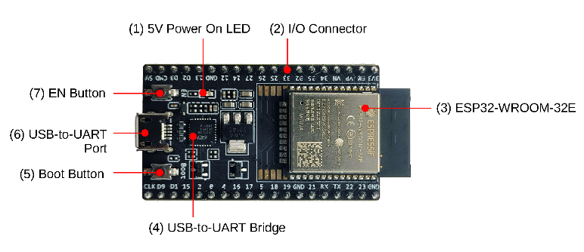
Figure ‎0—1ESP32 DevKit C development board

Table 2.1 compares the most common ESP32 variants. For this project the ESP32-WROOM-32 was chosen for the main controller because it provides enough GPIO pins, two hardware UARTs, a hardware I²C controller and integrated Wi-Fi/Bluetooth at the lowest cost, and the ESP32-CAM (also built on the WROOM module) was chosen for the video recorder because of its on-board camera and SD-card slot.
Table 1 Comparison of common ESP32 board variants
Variant | Core / clock | RAM | Flash | Wireless | Special feature
ESP32-WROOM-32 | Dual Xtensa LX6, 240 MHz | 520 KB | 4 MB | Wi-Fi + BT 4.2 | General-purpose, lowest cost
ESP32-WROVER-B | Dual Xtensa LX6, 240 MHz | 520 KB + 8 MB PSRAM | 4–16 MB | Wi-Fi + BT 4.2 | Large image buffers
ESP32-CAM (AI-Thinker) | Dual Xtensa LX6, 240 MHz | 520 KB + 4 MB PSRAM | 4 MB | Wi-Fi + BT 4.2 | On-board OV2640 camera + SD slot
ESP32-S3 | Dual Xtensa LX7, 240 MHz | 512 KB + up to 8 MB PSRAM | up to 16 MB | Wi-Fi + BT 5 LE | USB-OTG, AI vector extensions
ESP32-C3 | Single RISC-V, 160 MHz | 400 KB | 4 MB | Wi-Fi + BT 5 LE | Smallest, single-core, low cost

2.3.1 Architecture and Features
Figure 2.2 shows the simplified architecture of the dual-core variant used in the project. Two Xtensa LX6 cores share access to internal SRAM, to the on-package flash via the cache controller, and to a wide range of peripheral controllers: two SPI interfaces (HSPI and VSPI), two I²C interfaces, three UARTs, eighteen ADC channels, two DAC channels, sixteen PWM channels through the LEDC peripheral, a touch-sensor controller, and a CAN/TWAI controller.
Core 0Xtensa LX6 240 MHz Core 1Xtensa LX6 240 MHz 520 KB SRAM CrossbarBus matrix Wi-Fi b/g/n + BT 4.2 3 × UART, 2 × I²C HSPI + VSPI, SD/MMC 18 × ADC, 2 × DAC 16 × PWM (LEDC) CAN/TWAI, Touch, RTC

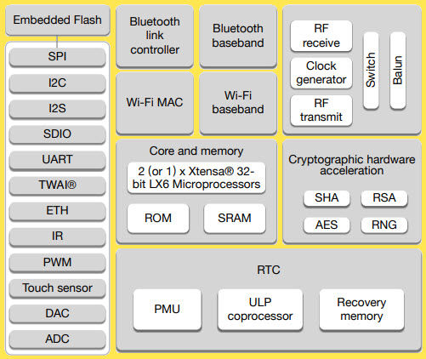
Figure ‎0—2ESP32 dual-core block diagram

2.3.2 Role of the ESP32 in the Project
In the present design the ESP32 plays two distinct roles, one for each board. The main-controller ESP32 reads the MPU6050 over I²C, the DS1302 over a three-wire serial link, the MQ-3 and the four LM35s through the ADC, the SW-420 through an interrupt-driven GPIO pin, and the SIM808 over a hardware UART; it then formats the readings into a single comma-separated telemetry frame and sends it to the camera board over a second UART. The camera-board ESP32 receives that frame, appends it to a plain-text log file on the SD card, and concurrently captures video from the on-board OV2640 sensor and writes it into segmented AVI files on the same card.
Figure 2.13 maps these resources together with the on-package and external flash and the PSRAM that is available on the ESP32-CAM. The dual-core processor, the bus matrix and the peripheral controllers all share access to the same address space, which simplifies driver development at the cost of slightly higher contention when one core is reading from the SPI flash while the other is doing I/O.
ESP32 memory map (typical WROOM-32) IRAM128 KB (code, ISRs) DRAM320 KB (heap + stack) RTC slow + fast RAM16 KB (deep sleep retain) ROM448 KB (boot, libs) External flash4 MB SPI flash(code + data + SPIFFS) External PSRAM4 MB (CAM only)Frame buffers Bus matrix PRO_CPU (core 0) APP_CPU (core 1) DMA channels Cache controller Peripheral bus to GPIO & modems

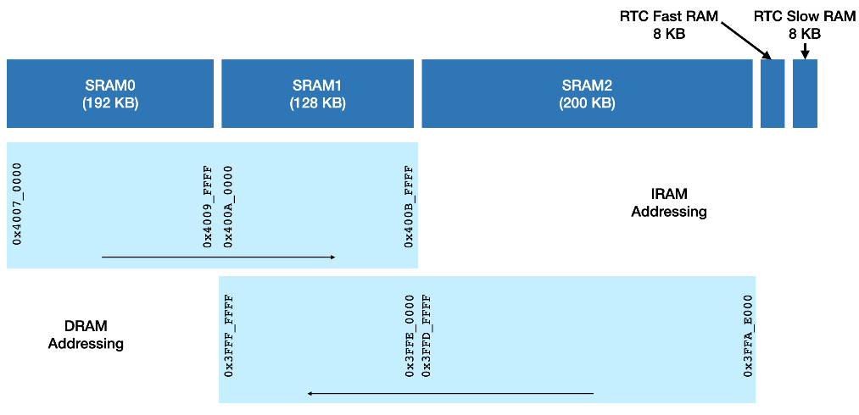
Figure ‎0—3 ESP32 internal memory map

2.4 MPU6050 Motion Sensor
The MPU6050 was developed by InvenSense (now part of TDK) as an integrated solution that combines a three-axis MEMS accelerometer and a three-axis MEMS gyroscope on a single silicon die, together with a digital motion processor and an I²C slave interface. The breakout board most commonly used in hobby and prototype work — carrying the part number GY-521 — exposes the sensor on a small PCB together with the necessary decoupling capacitors and a 3.3 V LDO, so that it can be powered directly from a 5 V or 3.3 V rail.
MPU-6050 VCCGNDSCLSDAXDAXCLADOINT

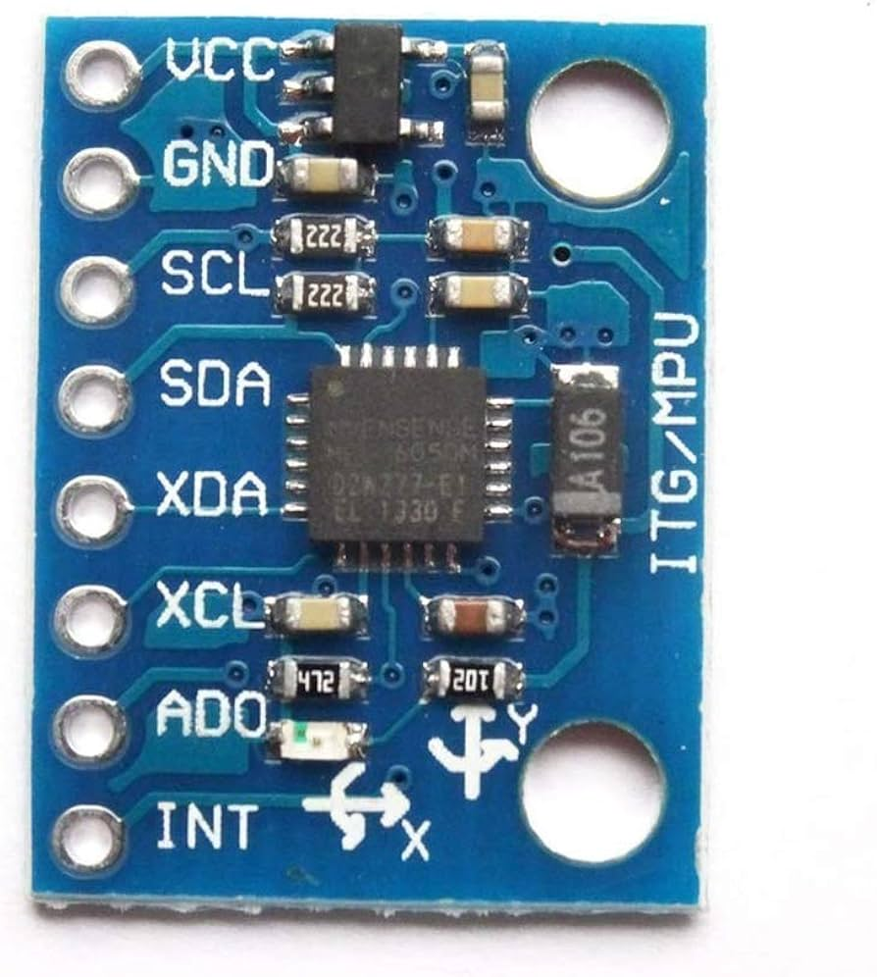
Figure ‎0—4MPU6050 (GY-521) IMU module

Internally the accelerometer is selectable across full-scale ranges of ±2 g, ±4 g, ±8 g and ±16 g, and the gyroscope across ±250, ±500, ±1000 and ±2000 °/s. The raw output of each axis is a 16-bit signed integer, so the relationship between the raw value and the engineering unit is governed by the full-scale range. For the ±2 g accelerometer setting used in this project the sensitivity is 16 384 LSB/g, and the conversion from raw value to acceleration in g is given by Eq. (2.1), which is implemented in the firmware as a simple division by the constant 16384.0.
a [g] = a_{raw} / 16384 (2.1)
To detect whether the vehicle is currently accelerating along its longitudinal axis, the firmware computes the difference between the current X-axis reading and a baseline value captured during a fifty-sample calibration sequence at boot. The decision rule used to populate the mpuMove string is given by Eq. (2.2):
if (a_{x} − a_{x,base}) > 0.08 g → FORWARD_ACCEL ; if < −0.08 g → BACKWARD_ACCEL ; else → STABLE (2.2)
Table 2Comparison of common IMU devices
Device | Accel. range | Gyro. range | Bus | Notes
MPU6050 | ±2/4/8/16 g | ±250…2000 °/s | I²C | 6 DOF, very low cost, ubiquitous
MPU9250 | ±2/4/8/16 g | ±250…2000 °/s | I²C / SPI | 9 DOF, adds magnetometer (AK8963)
BMI160 | ±2/4/8/16 g | ±125…2000 °/s | I²C / SPI | Lower power, smaller package
LSM6DS3 | ±2/4/8/16 g | ±125…2000 °/s | I²C / SPI | Built-in FIFO and step counter
ADXL345 (accel only) | ±2/4/8/16 g | — | I²C / SPI | 3 DOF, very mature, low cost

2.5 DS1302 RTC Module
The DS1302 is a Real-Time Clock chip from Maxim (originally Dallas Semiconductor) that maintains seconds, minutes, hours, day-of-week, date, month and year — including leap-year correction up to the year 2100 — and that communicates with the host microcontroller over a simple three-wire serial interface (RST, I/O and SCLK). The breakout used in this project includes a CR2032 coin cell, so the clock continues to run when the main system power is removed, which means that no manual time-setting is required after every reboot.
CR2032 DS1302 VCCGNDCLKDATRST
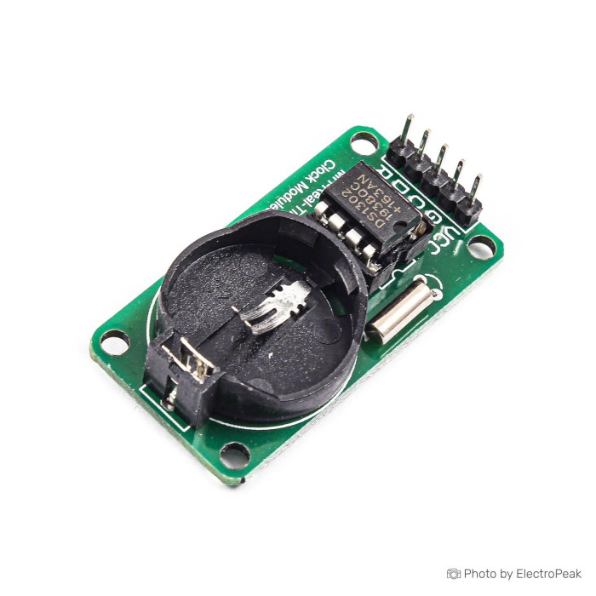
Figure ‎0—5 DS1302 RTC module
In this project the DS1302 is used to record the real date and time for each sensor reading and every logged event. Internally the time data is stored in BCD format; the RtcDS1302 driver used in the firmware handles the BCD/binary conversion transparently and exposes a RtcDateTime object whose accessors are used by the getRtcTime() function described in Section 4.5.
Table 3 Comparison of common RTC modules
Chip | Bus | Accuracy | Backup | Notes
DS1302 | 3-wire (RST/IO/SCLK) | ±1.7 min/month typ. | CR2032 | Lowest cost, no temperature compensation
DS1307 | I²C | ±2 min/month typ. | CR2032 | I²C, slightly higher cost
DS3231 | I²C | ±2 ppm (≈ 1 min/year) | CR2032 | TCXO inside, much higher accuracy
PCF8563 | I²C | ±30 ppm | CR2032 | Lower power, alarm interrupt

2.6 ESP32-CAM Module
The ESP32-CAM was developed by AI-Thinker as a specialised variant of the ESP32 with an integrated OV2640 camera and an SD/MMC card slot, addressing the need for low-cost imaging and visual recording in embedded systems. The module exposes the dedicated camera-interface pins of the ESP32 SoC together with the SD/MMC bus, and includes 4 MB of external PSRAM — an important detail, because the camera buffer cannot fit in the internal SRAM at VGA resolution.
OV2640 ESP32-S + 4 MB PSRAM microSD slot
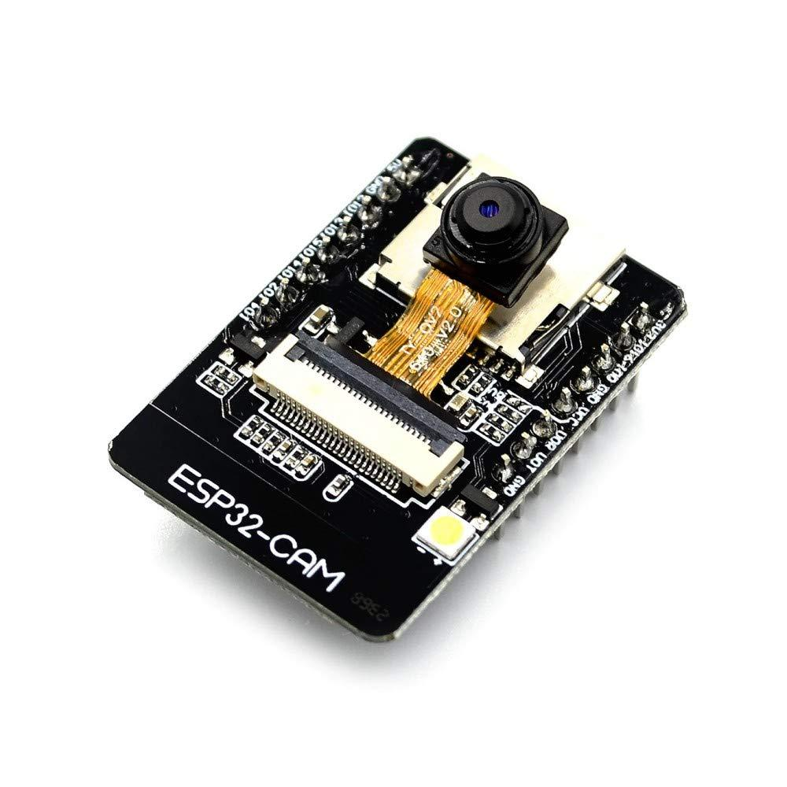
Figure ‎0—6AI-Thinker ESP32-CAM module
In this project the ESP32-CAM is used both as a video recorder and as the storage controller of the system. It captures JPEG frames from the OV2640 sensor at ten frames per second, writes them into a custom-built AVI/MJPEG container on the SD card, and at the same time receives the comma-separated telemetry frames from the main controller and appends them to a plain-text log file /car_log.txt on the same card. The AVI files are automatically split every thirty seconds so that an individual segment can be retrieved without having to seek through a multi-hour file.
Table 4ESP32-CAM image-sensor frame sizes (OV2640)
Constant | Resolution (px) | Typical JPEG size at Q=12 | Max FPS to SD
FRAMESIZE_QQVGA | 160 × 120 | ~5 kB | > 25
FRAMESIZE_QVGA | 320 × 240 | ~12 kB | ~20
FRAMESIZE_VGA | 640 × 480 | ~30 kB | ~10 (used)
FRAMESIZE_SVGA | 800 × 600 | ~45 kB | ~8
FRAMESIZE_XGA | 1024 × 768 | ~70 kB | ~5
FRAMESIZE_UXGA | 1600 × 1200 | ~160 kB | ~2

2.6.1 AVI File Structure
The Audio Video Interleave (AVI) format is a binary container defined on top of Microsoft’s Resource Interchange File Format (RIFF). Each AVI file is a sequence of chunks, where every chunk starts with a four-character identifier (FOURCC) and a four-byte little-endian length. Figure 2.6 illustrates the simplified layout of the AVI files generated by the camera firmware: a top-level RIFF chunk of type AVI contains a header list (hdrl) with the global parameters of the file, a movie list (movi) holding the JPEG frames as individual 00dc chunks, and an index (idx1) listing the position and size of every frame so that the file can be seek-played efficiently.
RIFF "AVI " <file size> LIST "hdrl" → avih + LIST "strl" (strh + strf) LIST "movi" 00dc frame 1 00dc frame 2 … idx1 (16-byte entry × N frames)
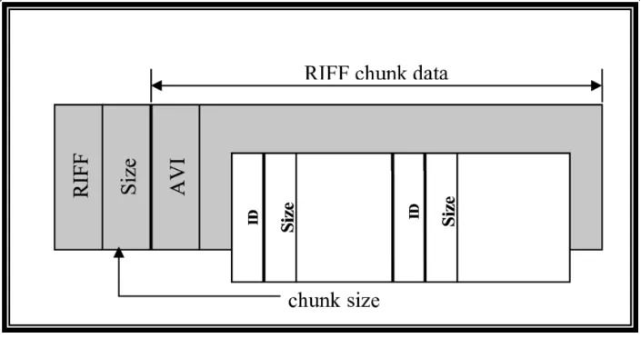
Figure ‎0—7 Simplified AVI container layout

2.7 SIM808 GSM/GPS Module
The SIM808 module was developed by SIMCom Wireless Solutions as a compact, integrated communication unit that combines two essential functions on a single board: a quad-band GSM/GPRS cellular modem and a GPS satellite receiver. This combination eliminates the need for two separate modules, simplifying the wiring of the black box and reducing power consumption — both important considerations in an embedded automotive system.
SIM808 SIMCom SIM holder GSM ANT GPS ANT

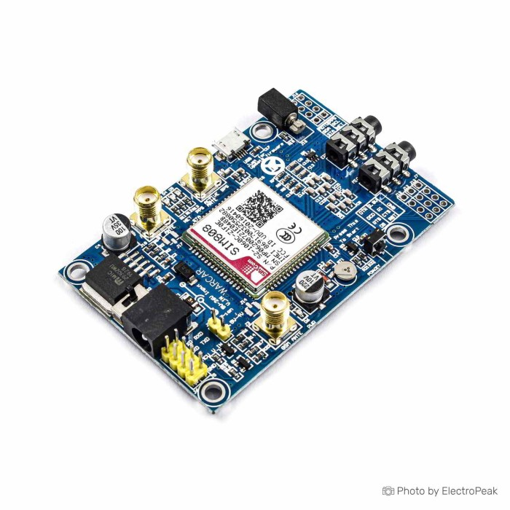
Figure ‎0—8 SIM808 GSM/GPS module
The GPS section of the module receives signals from the satellite constellation and computes the vehicle’s geographic position (latitude, longitude, altitude), its ground speed, and the UTC time. The result of a GNSS query, retrieved with the AT command AT+CGNSINF, is a single comma-separated line whose fields (run status, fix status, UTC time, latitude, longitude, altitude, speed, course…) are parsed by the parseCGNSINF() function described in Section 4.5. The GSM/GPRS section establishes a cellular data link with the mobile network, allowing the system to send SMS messages or HTTP/MQTT packets to a remote server.
Table 5 Comparison of common GNSS / cellular modules
Module | Cellular | GNSS | Power | Notes
SIM808 | Quad-band GSM/GPRS | GPS L1 | 2–5 W peak | Single board, low cost
SIM800L | Quad-band GSM/GPRS | None | 2–5 W peak | Cellular only, smaller
NEO-6M | None | GPS L1 | ~35 mA | GNSS only, very stable fix
SIM7000 | NB-IoT / LTE-M Cat M1 | GPS / GLONASS | ~1 W peak | Modern LTE replacement

2.8 MQ-3 Alcohol Sensor
The MQ-3 is a chemical gas sensor designed primarily to detect ethanol vapour in the surrounding air. It is built around a tin-dioxide (SnO₂) sensing element whose electrical resistance varies with the concentration of alcohol vapour in contact with it: as the alcohol concentration rises, the resistance falls, and this change is converted into an analogue voltage at the sensor’s output by a simple resistor divider.
MQ-3 LM393 Trim pot VCCGNDD0A0
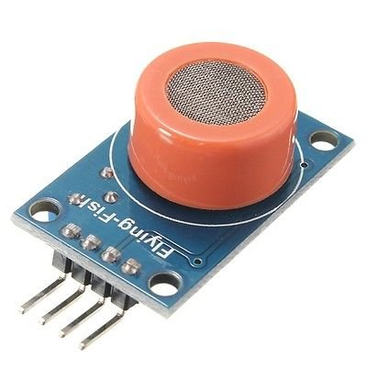
Figure ‎0—9 MQ-3 alcohol sensor module

The module has good sensitivity to ethanol and reasonable rejection of other common cabin gases. It requires a short warm-up period during which an internal heater brings the sensing element to its operating temperature; after warm-up, the sensor produces a stable reading. In this project the MQ-3 is mounted near the driver’s seat and read through one of the ESP32’s analogue-to-digital converter (ADC) channels. The microcontroller samples the analogue output periodically and compares it against a calibrated threshold; readings above the threshold are logged as an alcohol-detection event, recorded with their timestamp and GPS coordinates, and trigger a remote alert through the SIM808 module. The relationship between the raw 12-bit ADC count and the input voltage on the ESP32 is given by Eq. (2.3):
V_{in} = (adc_{raw} / 4095) × 3.3 V (2.3)

Table 6 Comparison of common gas-sensor families
Sensor | Target gas | Output | Notes
MQ-3 | Ethanol | Analogue + digital | Used here; high ethanol sensitivity
MQ-2 | LPG, methane, smoke | Analogue + digital | General combustible-gas detector
MQ-7 | Carbon monoxide | Analogue + digital | Requires heater cycling
MQ-135 | Air quality (NH₃, NOx, CO₂…) | Analogue + digital | Broad-spectrum, less selective
MICS-5524 | CO, ethanol, methane | Analogue | Lower power, smaller package

2.9 SW-420 (801s) Vibration Sensor
The SW-420 — often supplied as part of the 801s vibration-sensor module — is a simple but effective shock and vibration detector. At its core is a spring-loaded conductive element inside a sealed housing: when the housing is subjected to vibration or a sudden impact, the spring momentarily breaks the internal contact, producing a digital pulse on the module’s output pin. An on-board comparator (LM393) and a sensitivity potentiometer allow the trigger threshold to be tuned in hardware.
SW-420 LM393 Trim VCCGNDD0A0

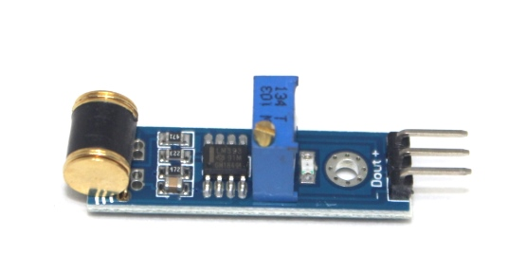
Figure ‎0—10 SW-420 (801s) vibration sensor module
Compared with the MPU6050 — which gives continuous numerical readings of acceleration along three axes — the SW-420 is a discrete event sensor: it does not measure the magnitude of an impact, but reports very quickly and reliably whether a significant shock has occurred. The two sensors therefore complement each other well. In this project the SW-420 is mounted on the chassis of the vehicle and its digital output is connected to one of the ESP32’s general-purpose input pins, configured to generate an interrupt on the rising edge through a function declared with the IRAM_ATTR attribute, so that the ISR is placed in internal RAM and can run even while the SPI flash is busy.

Table 7Comparison of common vibration / shock sensors
Device | Principle | Output | Notes
SW-420 | Spring contact | Digital pulse | Used here; threshold tunable
SW-18010P | Rolling-ball | Digital pulse | Cheapest, very crude
Piezo disc | Piezoelectric | Analogue spike | Magnitude information, needs amplifier
ADXL345 | MEMS accelerometer | Digital + interrupt | Programmable single/double tap

2.10 L298N Dual H-Bridge Motor Driver
The L298N is a classic dual full-bridge motor driver capable of sinking and sourcing up to 2 A per channel at a load voltage of up to 46 V. In hobby and educational projects it is most commonly supplied as a small ready-built breakout that exposes the two H-bridges, a 5 V on-board linear regulator, and screw terminals for the motor leads. In this project the L298N is used to drive the two DC gear motors of the demonstration chassis so that the rest of the firmware can be tested under realistic motion conditions before installation in a real vehicle.
L298N 2× H-bridge M A M B +5V LDO
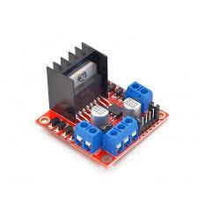
Figure ‎0—11 L298N dual H-bridge motor driver

Each H-bridge is controlled through three pins: two direction pins (IN1/IN2 or IN3/IN4) that determine the polarity of the voltage applied to the motor, and an enable pin (ENA or ENB) that accepts a PWM signal whose duty cycle sets the average voltage and therefore the speed of the motor. In the firmware the four direction pins are driven from the four GPIOs mapped in the // L298N block, and the two enable pins are driven by the ESP32’s built-in analogWrite(), which uses the LEDC peripheral to generate PWM at a configurable frequency.

Table 8 Comparison of common motor-driver ICs
Driver | Channels | Continuous current | Max voltage | Notes
L298N | 2 | 2 A | 46 V | Used here; cheap, large heat sink
L293D | 2 | 0.6 A | 36 V | Smaller, lower current
TB6612FNG | 2 | 1.2 A | 15 V | Higher efficiency MOSFET output
DRV8833 | 2 | 1.5 A | 10.8 V | Compact, low-voltage, modern

2.11 LM35 Temperature Sensor
The LM35 is a precision analogue temperature sensor whose output voltage is linearly proportional to the temperature in Celsius, at a slope of 10 mV per °C. The conversion from the input voltage measured at the ADC pin to the temperature in degrees Celsius is therefore given by Eq. (2.4):
T [°C] = V_{in} × 100 (2.4)
LM35 +VOUTGND
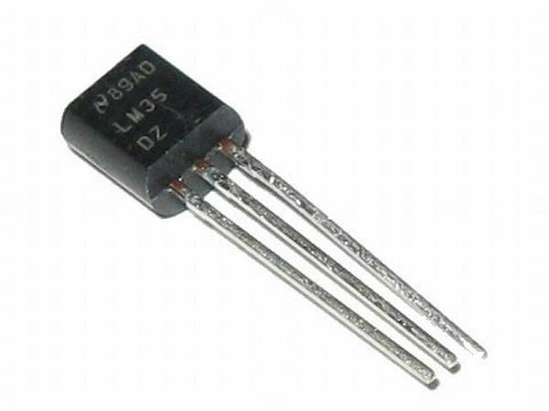
Figure ‎0—12 LM35 analogue temperature sensor
The sensor operates from any supply between 4 V and 30 V and draws less than 60 µA, which means that four of them can be powered from the 5 V rail of the ESP32 board without the need for an external regulator. In this project the four LM35s are routed to four separate ADC channels and read in the sendTelemetry() function shown in Section 4.5, so that the temperature of four critical points on the chassis is sampled at every telemetry tick.

Table 9 Comparison of common analogue temperature sensors
Device | Output | Range | Accuracy | Notes
LM35 | 10 mV/°C | 0…+100 °C | ±0.5 °C typ. | Used here; Celsius native
LM335 | 10 mV/K | −40…+100 °C | ±1 °C | Kelvin output, needs offset
TMP36 | 10 mV/°C + 500 mV offset | −40…+125 °C | ±1 °C | Handles negative temperatures
DS18B20 | 1-Wire digital | −55…+125 °C | ±0.5 °C | Digital, multiple on one bus

2.12 Communication Protocols
The choice of communication protocol between each sensor and the main controller has a direct impact on the wiring complexity, the maximum data rate, and the noise immunity of the system. The present design uses four different protocols, each suited to its sensor.

2.12.1 I²C (Inter-Integrated Circuit)
I²C is a two-wire synchronous serial bus — SDA for data and SCL for the clock — that allows multiple slave devices to share the same pair of lines, each identified by a unique 7-bit address. In this project the MPU6050 is the only I²C slave attached to the main controller, but the protocol was still preferred over a hand-rolled SPI bit-bang because the ESP32 includes a hardware I²C controller that takes care of the clock stretching, start/stop conditions, and ACK/NACK signalling automatically.
Master ESP32 SDA SCL Slave 1 Slave 2 Slave 3 R↑ R↑

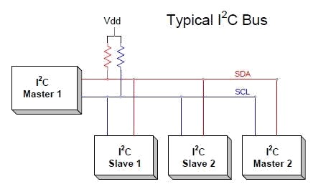
Figure ‎0—13 I²C bus topology

The bus protocol itself is shown in Figure 2.14. A complete transaction begins with the master generating a START condition (a falling edge on SDA while SCL is high), then clocks the seven-bit slave address followed by an R/W bit out on SDA. The addressed slave answers by pulling SDA low during the ninth clock pulse (ACK). Data bytes follow, each acknowledged by the receiver, and the transaction ends with a STOP condition (a rising edge on SDA while SCL is high).
SDA SCL S START A6–A0 + R/W ACK D7–D0 ACK P STOP

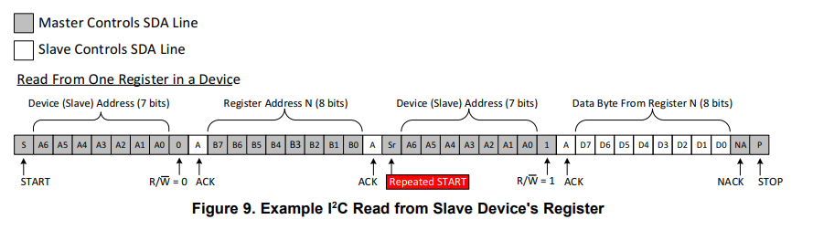
Figure ‎0—14 I²C transaction timing (START, 7-bit address, R/W, ACK, data byte, ACK, STOP)

2.12.2 UART (Universal Asynchronous Receiver/Transmitter)
UART is an asynchronous, full-duplex, point-to-point serial protocol that uses one wire in each direction (TX and RX) plus a common ground. There is no shared clock; instead, both ends agree on a baud rate, on the number of data bits, on the parity, and on the number of stop bits. In this project two independent UART links are used: the main controller talks to the SIM808 module at 9 600 baud over UART2 (GPIO16/17), and at the same time it sends telemetry to the ESP32-CAM at 115 200 baud over UART0 (the same UART that is connected to the USB-to-serial converter on the development board).

2.12.3 SPI / SD_MMC
The ESP32-CAM communicates with the microSD card through the SD_MMC interface, which is a four-bit-wide MultiMediaCard protocol that is electrically and protocol-wise different from the SPI mode used on many smaller microcontrollers. SD_MMC is much faster — up to roughly 20 MB/s on cheap cards — which makes the continuous video writing possible. The Arduino library used in the firmware exposes this through the call SD_MMC.begin("/sdcard", true), where the true selects 1-bit mode (used because the ESP32-CAM’s GPIO4 also drives the on-board LED and would otherwise conflict).

2.12.4 GPIO and Interrupts
The simplest interface used in the project is a plain digital GPIO, configured as an input with a hardware interrupt. This is how the SW-420 vibration sensor signals an impact: the firmware calls attachInterrupt(digitalPinToInterrupt(VIB_PIN), vibrationISR, RISING), and as soon as the spring contact opens the ESP32 jumps into the ISR, sets a single flag, and returns. The flag is then consumed by the next telemetry frame.
Table 10 Comparison of embedded serial protocols
Protocol | Topology | Wires | Typical speed | Used for
I²C | Multi-drop | 2 + GND | 100…400 kHz | MPU6050
UART | Point-to-point | 2 + GND | 9.6…921 kbaud | SIM808, ESP32⇒CAM
SPI | Master/slave | 3…4 + GND | 1…40 MHz | (general purpose)
SD_MMC (1-bit) | Master/slave | 3 + GND | up to 20 MB/s | SD card on ESP32-CAM
3-wire (DS1302) | Master/slave | 3 + GND | 2 Mbit/s max | DS1302 RTC

2.13 Conclusion of Chapter Two
This chapter has covered the theoretical study of the project’s components: the operating principle of the car black box and the role of the ESP32 microcontroller as the core of the system. It has also reviewed each of the supporting modules — the MPU6050 inertial unit, the DS1302 RTC, the ESP32-CAM imaging module, the SIM808 GPS/GSM module, the MQ-3 alcohol sensor, the SW-420 vibration sensor, the L298N motor driver and the LM35 temperature sensors — explaining the type of data each provides, the equations governing its operation, the alternatives available in the market, and the communication protocol selected. The chapter has contributed to building a clear understanding of how each component works and why it was selected for the project, and prepares the ground for the practical implementation discussed in Chapter 3.

Chapter 3
Practical Implementation

3.1 Introduction
Having established the theoretical background of each component in Chapter 2, this chapter turns to the practical side of the design. It begins with an inventory of the parts that make up the proposed system, justifies the choice of the ESP32 over comparable platforms, lays out the pin assignment for the two microcontroller boards, estimates the power budget and the storage budget, describes the operating mechanism of the system from power-up to shutdown, and ends with the block diagram that summarises the interconnections.

3.2 Main Project Components
The proposed black box system consists of a set of carefully selected electronic and mechanical components, chosen to achieve the project’s objectives. These components are described below.

3.2.1 ESP32 Main Controller
The ESP32 main controller is responsible for reading every sensor on the board, formatting the readings into a single telemetry frame, and forwarding that frame both to the camera-side ESP32 and (when triggered) to the SIM808 cellular modem.

3.2.2 ESP32-CAM Recorder
The ESP32-CAM module captures continuous video, writes it into segmented AVI files on the SD card, and appends the incoming telemetry frames to a plain-text log file on the same card.

3.2.3 MPU6050 Motion Sensor
The MPU6050 measures acceleration and angular velocity along the three axes and is the main source of motion data for the post-incident analysis.

3.2.4 DS1302 RTC Module
The DS1302 supplies the real date and time to which every reading is referenced; thanks to its backup coin cell, the time is preserved across power cycles.

3.2.5 SD Memory Card
A standard 32 GB microSD card stores the recorded video clips and the telemetry log; it is plugged into the slot on the ESP32-CAM and accessed in 1-bit SD_MMC mode.

3.2.6 SIM808 GSM/GPS Module
The SIM808 combines GPS positioning and GSM/GPRS cellular communication on a single board; it tags every telemetry frame with the current geographic coordinates and transmits remote alerts on critical events.

3.2.7 MQ-3 Alcohol Sensor
The MQ-3 measures the ethanol concentration in the cabin air and feeds an analogue voltage to one of the ESP32’s ADC channels.

3.2.8 SW-420 Vibration Sensor
The SW-420 reports sudden impacts as a digital pulse and is wired to an interrupt-capable GPIO pin on the ESP32.

3.2.9 L298N Motor Driver and DC Motors
The L298N drives the two DC gear motors of the demonstration chassis, allowing the rest of the system to be exercised under realistic motion conditions.

3.2.10 LM35 Temperature Sensors
Four LM35 sensors monitor temperatures at critical points (motor bearings, battery enclosure, cabin air) and provide an early warning of thermal anomalies.

3.3 Comparison between ESP32, Arduino and Raspberry Pi
The choice between an Arduino UNO, an ESP32 board and a Raspberry Pi single-board computer is the first major architectural decision in any project of this kind. Table 3.1 compares the three options against the criteria that matter for the present design: raw computing power, available memory, number of usable GPIO pins, native wireless support, ease of camera attachment, real-time response and power consumption. The ESP32 was selected because it sits at the sweet spot of the three: enough RAM and CPU to run the AVI writer and to drive the cellular modem at the same time, much more I/O than the Arduino, predictable real-time behaviour that a full Linux board such as the Raspberry Pi cannot guarantee, and a power footprint that is compatible with a battery-backed embedded system.
Table 11 Comparison between ESP32, Arduino UNO and Raspberry Pi
Aspect | Arduino UNO | ESP32 (this project) | Raspberry Pi 4
Processor | 8-bit ATmega328P, 16 MHz | Dual 32-bit Xtensa LX6, 240 MHz | Quad-core Cortex-A72, 1.5 GHz
RAM | 2 KB | 520 KB (+ 4 MB PSRAM on CAM) | 2–8 GB
Flash / storage | 32 KB | 4 MB | microSD (typ. 16–128 GB)
Usable GPIO | 14 digital + 6 analogue | up to 34, with ADC/DAC/PWM | 40-pin header
Networking | None native | Wi-Fi b/g/n + BT 4.2 built-in | Wi-Fi 5 + BT 5 + Gigabit Ethernet
Camera | External SPI camera | ESP32-CAM with on-board OV2640 | CSI-2 with high-quality cameras
Real-time response | Bare-metal, deterministic | Deterministic via FreeRTOS | Soft real-time (Linux scheduler)
Power consumption | ~50 mA active | ~80 mA active, < 10 µA deep sleep | ~600 mA active
Cost | Low | Very low | Higher

3.4 Pin Assignment Tables
Tables 2 and 3 list every GPIO pin used by the two ESP32 boards, together with its electrical function and the module to which it is connected. Following these tables when wiring the prototype is essential because the ESP32 has a large number of strapping and reserved pins that cannot be used freely.
Table 12 Main controller pin assignment
ESP32 pin | Function | Connected to
GPIO21 | I²C SDA | MPU6050 SDA
GPIO22 | I²C SCL | MPU6050 SCL
GPIO19 | 3-wire RST | DS1302 RST
GPIO18 | 3-wire DAT | DS1302 DAT
GPIO5 | 3-wire CLK | DS1302 CLK
GPIO16 | UART2 RX | SIM808 TX
GPIO17 | UART2 TX | SIM808 RX
GPIO13 | PWM ENA | L298N ENA
GPIO12 | Direction IN1 | L298N IN1
GPIO14 | Direction IN2 | L298N IN2
GPIO27 | Direction IN3 | L298N IN3
GPIO26 | Direction IN4 | L298N IN4
GPIO25 | PWM ENB | L298N ENB
GPIO23 | Digital input, interrupt | SW-420 D0
GPIO32 | ADC1_CH4 | MQ-3 A0
GPIO33 | ADC1_CH5 | LM35 #1
GPIO34 | ADC1_CH6 (input only) | LM35 #2
GPIO35 | ADC1_CH7 (input only) | LM35 #3
GPIO4 | ADC2_CH0 | LM35 #4
GPIO1 / TXD0 | UART0 TX | ESP32-CAM RX
GPIO3 / RXD0 | UART0 RX | ESP32-CAM TX

Table 13ESP32-CAM pin assignment
ESP32-CAM pin | Function | Notes
GPIO0 | Camera XCLK | 20 MHz pixel-clock to OV2640
GPIO26 | SCCB SDA | Camera control
GPIO27 | SCCB SCL | Camera control
GPIO5, 18, 19, 21, 36, 39, 34, 35 | Camera data bus Y2..Y9 | 8-bit parallel
GPIO25 | Camera VSYNC | Vertical sync
GPIO23 | Camera HREF | Horizontal reference
GPIO22 | Camera PCLK | Pixel clock
GPIO32 | Camera PWDN | Power-down (active high)
GPIO4 | On-board LED / flash | Set HIGH at boot
GPIO2, 14, 15 | SD_MMC CMD/CLK/DATA | 1-bit SD interface
GPIO1 / TXD0 | UART0 TX | To main ESP32 RX
GPIO3 / RXD0 | UART0 RX | From main ESP32 TX

3.5 Power Distribution
The system is powered from a single 12 V automotive feed taken from the ignition-switched accessory line. A buck converter steps that voltage down to 5 V for the two ESP32 boards, the SIM808 module and the LM35 sensors, and the 3.3 V LDOs that are integrated on each ESP32 development board derive the logic-level supply for the I²C and UART pull-ups. The L298N is fed directly from the 12 V rail because the H-bridge needs the full voltage to drive the motors at the rated speed. Table 3.4 gives the order-of-magnitude power budget of the system; the SIM808 dominates the peak current because its cellular transmitter draws bursts of up to 2 A during a connection attempt.
Table 14 Power-budget estimate of the system
Block | Voltage | Average current | Peak current
ESP32 main controller | 5 V | 80 mA | 240 mA (Wi-Fi TX)
ESP32-CAM + OV2640 | 5 V | 180 mA | 280 mA
SIM808 (idle + TX) | 5 V | 60 mA | 2 A (TX burst)
MPU6050 | 3.3 V | 4 mA | 4 mA
DS1302 | 3.3 V | 0.3 mA | 1 mA
MQ-3 + heater | 5 V | 150 mA | 150 mA
SW-420 + LM393 | 5 V | 5 mA | 5 mA
LM35 × 4 | 5 V | 0.24 mA | 0.24 mA
L298N (no-load logic) | 5 V | 40 mA | 40 mA
DC motors | 12 V | 500 mA | 1.5 A (stall)
Total budget | — | ~1.0 A | ~4 A peak
single 12 V vehicle feed enters the prototype and is split between a buck-converter that produces the 5 V logic rail and a direct feed to the L298N H-bridge. The on-board 3.3 V LDOs of the two ESP32 boards derive the logic-level rail for the MPU6050, the DS1302 and the I²C/UART pull-ups.
12 V vehicle rail (ignition-switched) Buck 12 V → 5 V 3 A continuous L298N (12 V) to DC motors ESP32 main ESP32-CAM SIM808 MQ-3 heater SW-420 logic LM35 × 4 L298N 5 V logic 3.3 V LDO on ESP32 3.3 V to MPU6050, DS1302
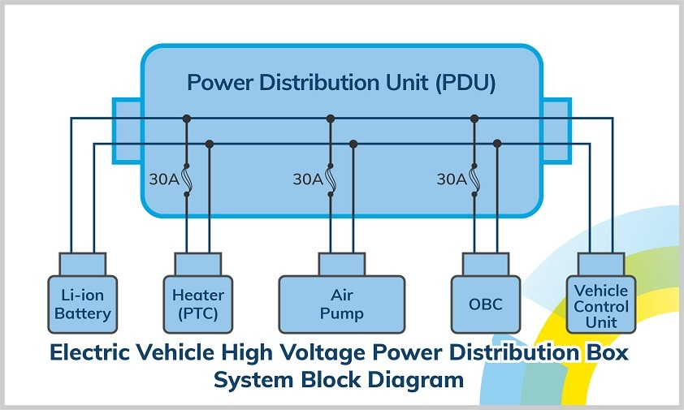
Figure ‎0—1 Power-distribution tree from the 12 V vehicle rail to the individual modules

3.6 System Operating Mechanism
When the ignition is switched on, the 12 V rail energises the buck converter and the entire system comes up at the same time. The two ESP32 boards execute their setup() routines in parallel: the main controller initialises the I²C and three-wire buses, brings the SIM808 out of reset, performs the fifty-sample accelerometer calibration, attaches the vibration interrupt and starts the motor on a periodic forward/backward demo cycle; the camera-side ESP32 powers up the OV2640, initialises the SD card, opens the first AVI segment and pulls the flash LED high. Once both boards are running, the main controller starts producing telemetry frames every five hundred milliseconds and writes them to its UART; the camera reads each frame, appends it to /car_log.txt, and continues to capture frames at ten per second. Every thirty seconds the camera closes the current AVI segment, writes the index, and opens a new one. The synchronous recording continues automatically without user intervention until power is removed, at which point the SD-card driver closes any open files cleanly.

3.7 Block Diagram
Figure 3.1 brings the full system into a single picture. The arrows are oriented along the direction of data flow: motion data, time, location and analogue voltages converge on the main controller; the main controller serialises them into a CSV frame and pushes it to the ESP32-CAM, which combines it with the video stream and writes both to the SD card.
ESP32 main controller MPU6050 DS1302 RTC MQ-3 alcohol SW-420 vib. LM35 × 4 SIM808 GSM/GPS ESP32-CAM microSD L298N ⇒ motors I²C / 3-wire / ADC / IRQ / UART UART CSV telemetry PWM + direction
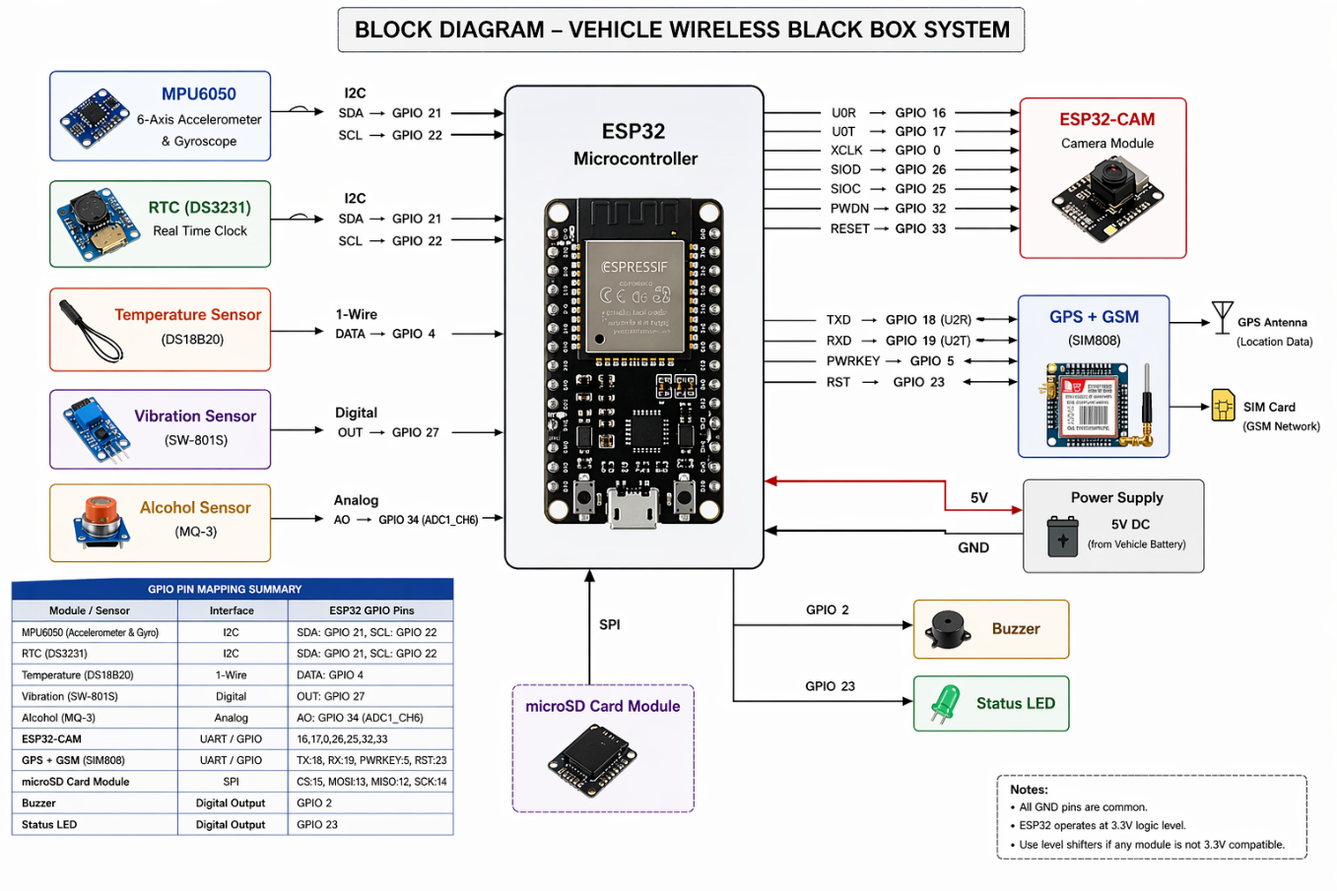
Figure ‎0—2 Block diagram of the wireless black box system
The same system can also be viewed from the standpoint of the data that flows through it, which is the perspective of Figure 3.3. The six sensor blocks on the left feed the main controller through five different physical interfaces (I²C, three-wire, ADC, GPIO with hardware interrupt, and UART). The main controller assembles their readings into a single CSV telemetry line and pushes the line to the ESP32-CAM, which appends it to the SD log alongside the video clips. A critical-event check at the bottom of the main loop can divert the same data path to the SIM808’s GSM modem for immediate SMS notification.
MPU6050 (a, ω) DS1302 (date/time) MQ-3 (alcohol V) SW-420 (impact) LM35 × 4 (°C) SIM808 GPS (lat, lon) ESP32 main controller readMPU(), readLM35(), updateGPS(), telemetry() Critical-event check VIB / MQ3 / SPEED ESP32-CAM video + log writer microSD /REC_*.avi, /car_log.txt SMS recipient family / fleet / 911 I²C / 3-w / ADC / IRQ / UART UART CSV 115k2 SD_MMC 1-bit SMS via SIM808 GSM

3.8 Conclusion of Chapter Three
This chapter has focused on the implementation and design aspects of the project, listing the main components of the system, justifying the choice of the ESP32 over comparable platforms, laying out the complete pin assignment for both boards, presenting the power and storage budgets, describing the operating mechanism from power-up to shutdown and ending with the block diagram. The chapter has provided a clear picture of the structure of the system and has prepared the ground for the discussion of the firmware and the test results that follows in Chapter 4.

Chapter 4
Results and Discussion

4.1 Introduction
This chapter presents the firmware of the two ESP32 boards in the form actually loaded onto the prototype, supports each major routine with a flowchart, derives the numerical relationships used in the firmware, and reports the results of the practical experiments carried out on the integrated system. The code is presented in the order in which it executes at run-time: the main controller is described first (Section 4.5) because it owns all the sensors and is the source of the telemetry stream; the camera recorder follows (Section 4.6); the equations that the firmware applies in real time are collected in Section 4.7; and the measurements taken during bench and road testing are reported in Section 4.8.

4.2 System Flowchart
Figure 4.1 gives the top-level operational flowchart of the integrated system, viewed from the user’s side. It is intentionally coarse: every block in the figure corresponds to a sub-system that has its own internal logic, and the more detailed flowcharts of the individual routines (setup, loop, ISR, recording cycle, segment lifecycle) are given in the sections that describe the corresponding code.
Ignition ON Power up both ESP32 boards Initialise sensors & SIM808 Start AVI segment + log file Record video & sensor data,split every 30 s Critical event?(VIB / MQ-3 / SPEED) Send SMS via SIM808 Ignition OFF YES NO
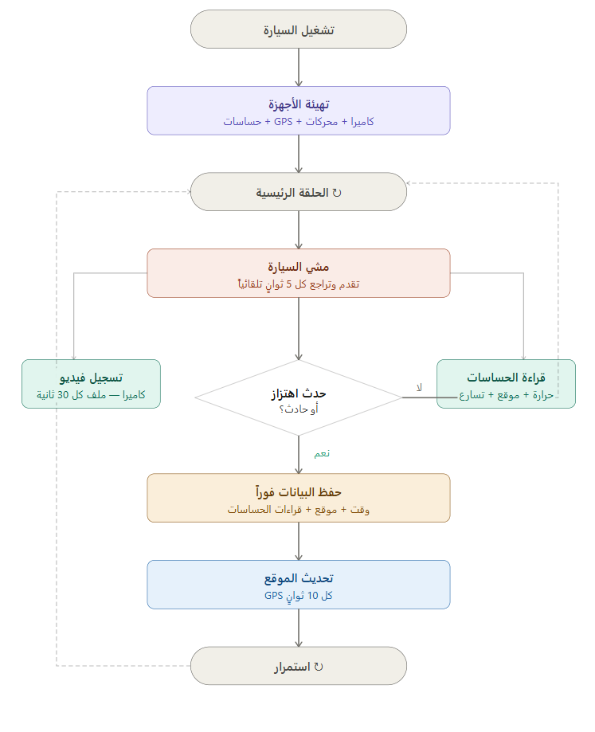
Figure ‎0—1 Data-flow block diagram of the integrated system

4.3 Practical Wiring of the Project
All system components were connected according to the pin assignment of Tables 3.2 and 3.3. The MPU6050 sensor was wired to the I²C bus of the main controller, the DS1302 RTC to the three-wire interface, the SIM808 module to one of the ESP32’s hardware UARTs through a dedicated power line capable of handling the brief current spikes drawn by the cellular transmitter, the MQ-3 to an analogue input pin, and the SW-420 to an interrupt-capable GPIO pin so that impact events are captured immediately, without polling. The four LM35 temperature sensors were attached to four separate ADC channels, and the L298N motor driver was wired to the six PWM/direction pins. The ESP32-CAM module was equipped with a 32 GB microSD card to store both the AVI files and the log. The use of an ESP shield helped to organise the wiring and reduce electrical complexity.
ESP32 ESP32-CAM UART MPU RTC MQ-3 VIB LM35 microSD
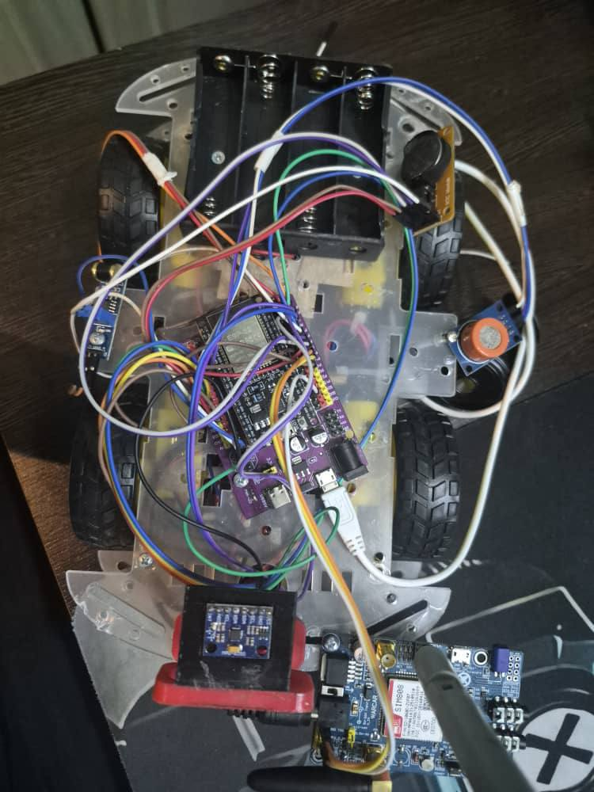
Figure ‎0—2

4.4 Runtime Operating Mechanism
When the car is started, the ESP32 microcontroller begins initialising all connected units. The MPU6050 motion sensor and the DS1302 module are activated, the SIM808 module is brought up and configured to power the GNSS receiver with AT+CGNSPWR=1, the MQ-3 alcohol sensor is given its short warm-up period, the SW-420 vibration sensor is attached to an interrupt-driven GPIO pin, and the ESP32-CAM module begins recording video automatically as soon as its setup() ends.
During the operating period, motion and orientation data are sampled from the MPU6050 on every iteration of the main loop, the GPS is polled every ten seconds with AT+CGNSINF, telemetry is emitted every five hundred milliseconds, and the demonstration chassis is alternated between forward and backward every five seconds so that the rest of the system is exercised under realistic motion conditions. The camera continuously captures JPEG frames at ten per second and writes them into the open AVI segment; the segment is closed and a new one is opened every thirty seconds. Any critical event triggers an SMS alert over the SIM808’s GSM channel and is logged with the corresponding timestamp and GPS coordinates.

4.5 ESP32 Main-Controller Code
The firmware of the main controller is contained in a single Arduino sketch (carcode.ino) which is reproduced below in five logical blocks. Each block is preceded by a short paragraph that summarises its purpose, and the two top-level routines (setup() and loop()) are accompanied by flowcharts (Figures 4.3 and 4.4).

4.5.1 Headers, Pin Definitions and Global State
The sketch begins by including the Arduino core, the Wire library that provides the I²C driver, and the ThreeWire / RtcDS1302 libraries that handle the proprietary three-wire bus of the DS1302. It then defines a symbolic name for every GPIO pin used in the design (with the assignment given in Table 3.2) and declares the globals that hold the latest sensor readings, the GPS fields decoded from the SIM808, the demo motor state, and a small set of timers that drive the periodic tasks.
#include <Arduino.h>
#include <Wire.h>
#include <ThreeWire.h>
#include <RtcDS1302.h>

// MPU6050
#define MPU_ADDR 0x68
#define MPU_SDA 21
#define MPU_SCL 22

// L298N motor driver
#define ENA 13
#define IN1 12
#define IN2 14
#define IN3 27
#define IN4 26
#define ENB 25

// SIM808 GPS / GSM on UART2
#define SIM808_RX 16 // ESP32 RX <-- SIM808 TX
#define SIM808_TX 17 // ESP32 TX --> SIM808 RX

// DS1302 three-wire RTC
#define RTC_RST 19
#define RTC_DAT 18
#define RTC_CLK 5

// Discrete sensors
#define VIB_PIN 23
#define MQ3_PIN 32
#define LM35_1 33
#define LM35_2 34
#define LM35_3 35
#define LM35_4 4

// ESP32-CAM uses Serial0 (TX0/RX0)

ThreeWire myWire(RTC_DAT, RTC_CLK, RTC_RST);
RtcDS1302<ThreeWire> Rtc(myWire);
HardwareSerial sim808(2);

String gpsRaw, gpsFix = "0", gpsLat, gpsLon, gpsAlt, gpsSpeed;
float ax_g = 0, ay_g = 0, az_g = 0, baseAx = 0;
String mpuMove = "STILL";

unsigned long moveTimer = 0, teleTimer = 0, gpsTimer = 0;
const unsigned long MOVE_PERIOD = 5000;
const unsigned long TELE_PERIOD = 500;
const unsigned long GPS_PERIOD = 10000;

bool forwardState = true;
int motorSpeed = 180;
volatile bool vibrationDetected = false;

4.5.2 Motor Control and Vibration ISR
The motor driver is controlled by three groups of pins per channel as described in Section 2.10. The helper functions stopMotors(), moveForward() and moveBackward() set the four direction pins and call analogWrite() on the two enable pins to apply the desired PWM duty cycle. The vibration sensor is handled by the interrupt service routine vibrationISR(), which is placed in internal RAM with the IRAM_ATTR attribute so that it remains callable even while the SPI flash is being read. The ISR sets a single boolean flag; this minimises the time spent in interrupt context and avoids the well-known pitfall of calling non-reentrant routines from an ISR.
void IRAM_ATTR vibrationISR() {
vibrationDetected = true;
}

void stopMotors() {
digitalWrite(IN1, LOW); digitalWrite(IN2, LOW);
digitalWrite(IN3, LOW); digitalWrite(IN4, LOW);
analogWrite(ENA, 0); analogWrite(ENB, 0);
}

void moveForward() {
digitalWrite(IN1, HIGH); digitalWrite(IN2, LOW);
digitalWrite(IN3, HIGH); digitalWrite(IN4, LOW);
analogWrite(ENA, motorSpeed); analogWrite(ENB, motorSpeed);
}

void moveBackward() {
digitalWrite(IN1, LOW); digitalWrite(IN2, HIGH);
digitalWrite(IN3, LOW); digitalWrite(IN4, HIGH);
analogWrite(ENA, motorSpeed); analogWrite(ENB, motorSpeed);
}

4.5.3 MPU6050 Initialisation, Reading and Calibration
The MPU6050 driver in this sketch is intentionally written by hand instead of relying on a third-party library, so that the I²C transactions are explicit and easy to debug. The function mpuWrite() writes a single byte to a sensor register, mpuRead() reads n bytes starting from a register address, and be16() combines two consecutive bytes into a signed 16-bit value in big-endian order. The accelerometer is initialised in ±2 g range (sensitivity 16 384 LSB/g) by writing 0x00 to register 0x1C, and brought out of sleep mode by writing 0x00 to register 0x6B. The calibrateMPU() routine averages fifty samples of the longitudinal axis to capture the bias due to the orientation of the sensor, and stores the result in baseAx for use by Eq. (2.2).
bool mpuWrite(uint8_t reg, uint8_t val) {
Wire.beginTransmission(MPU_ADDR);
Wire.write(reg); Wire.write(val);
return Wire.endTransmission() == 0;
}

bool mpuRead(uint8_t reg, uint8_t *data, uint8_t len) {
Wire.beginTransmission(MPU_ADDR);
Wire.write(reg);
if (Wire.endTransmission(false) != 0) return false;
uint8_t got = Wire.requestFrom(MPU_ADDR, len, true);
if (got != len) return false;
for (int i = 0; i < len; i++) data[i] = Wire.read();
return true;
}

int16_t be16(uint8_t hi, uint8_t lo) {
return (int16_t)((hi << 8) | lo);
}

void initMPU() {
mpuWrite(0x6B, 0x00); // wake from sleep
mpuWrite(0x1C, 0x00); // accel ±2 g
}

void readMPU() {
uint8_t b[6];
if (!mpuRead(0x3B, b, 6)) { ax_g = ay_g = az_g = 0; return; }

int16_t axRaw = be16(b[0], b[1]);
int16_t ayRaw = be16(b[2], b[3]);
int16_t azRaw = be16(b[4], b[5]);

ax_g = axRaw / 16384.0;
ay_g = ayRaw / 16384.0;
az_g = azRaw / 16384.0;

float diff = ax_g - baseAx;
if (diff > 0.08) mpuMove = "FORWARD_ACCEL";
else if (diff < -0.08) mpuMove = "BACKWARD_ACCEL";
else mpuMove = "STABLE";
}

void calibrateMPU() {
float sum = 0;
for (int i = 0; i < 50; i++) { readMPU(); sum += ax_g; delay(20); }
baseAx = sum / 50.0;
}
Figure 4.8 illustrates the calibration loop graphically: the routine averages fifty consecutive samples of the longitudinal axis and stores the result in baseAx, so that subsequent reads can subtract the static bias due to the orientation of the sensor on the chassis.
calibrateMPU() start sum = 0, i = 0 i < 50? readMPU() → ax_g sum += ax_g; delay(20); i++ baseAx = sum / 50 return NO YES

4.5.4 RTC, Analogue Sensors and GPS Decoding
The RTC driver returns a RtcDateTime object whose accessors are formatted by getRtcTime() into an ISO-8601 string. The two analogue helper functions convert the raw ADC value into engineering units by applying Eq. (2.3) for the input voltage and Eq. (2.4) for the LM35 temperature. The GPS decoder receives lines from UART2, looks for the +CGNSINF: prefix that the SIM808 emits in response to AT+CGNSINF, splits the comma-separated payload into fields, and stores the run status, fix status, latitude, longitude, altitude and ground speed into the corresponding globals; an AT+CGNSINF request is re-issued every ten seconds by updateGPS().
String getRtcTime() {
RtcDateTime now = Rtc.GetDateTime();
char buf[32];
snprintf(buf, sizeof(buf), "%04u-%02u-%02u %02u:%02u:%02u",
now.Year(), now.Month(), now.Day(),
now.Hour(), now.Minute(), now.Second());
return String(buf);
}

float readLM35(int pin) {
int adc = analogRead(pin);
float voltage = adc * (3.3 / 4095.0);
return voltage * 100.0; // 10 mV / °C
}

float readMQ3Voltage() {
int adc = analogRead(MQ3_PIN);
return adc * (3.3 / 4095.0);
}

void sendGPSCommand(String cmd) { sim808.println(cmd); }

void parseCGNSINF(String line) {
gpsRaw = line;
String parts[20];
String value = "";
int idx = 0;
for (int i = 0; i < line.length(); i++) {
char c = line[i];
if (c == ',' || c == ':') {
parts[idx++] = value;
value = "";
if (idx >= 20) break;
} else {
value += c;
}
}
if (idx < 6) return;
gpsFix = parts[2]; gpsLat = parts[4];
gpsLon = parts[5]; gpsAlt = parts[6];
gpsSpeed = parts[7];
}

void updateGPS() {
while (sim808.available()) {
String line = sim808.readStringUntil('\n');
line.trim();
if (line.startsWith("+CGNSINF:")) parseCGNSINF(line);
}
if (millis() - gpsTimer >= GPS_PERIOD) {
gpsTimer = millis();
sendGPSCommand("AT+CGNSINF");
}
}
Figure 4.9 shows the corresponding flowchart for updateGPS(). The routine first drains any unread bytes from the SIM808’s UART, parses any +CGNSINF: line it encounters, and — if at least ten seconds have elapsed since the previous request — issues a fresh AT+CGNSINF command. This approach keeps the cellular bus traffic low while still producing a position update at the rate the rest of the firmware expects.
updateGPS() sim808.available()? line = readStringUntil('\n') line.startsWith("+CGNSINF:")? parseCGNSINF(line) millis − gpsTimer ≥ 10 s? send AT+CGNSINF NO NO YES

4.5.5 Telemetry Frame, setup() and loop()
The telemetry frame is the heart of the system. The function sendTelemetry() reads every sensor exactly once, packages the readings into a single line in the form REC=s,RTC=…,MQ3_RAW=…,VIB=…,LAT=…,LON=…,… and writes it to Serial; the ESP32-CAM picks the line up and appends it to the SD log. The REC=s token tells the recorder that recording must remain active. After emitting the frame the function clears the vibrationDetected flag so that the next ISR fires correctly. The setup() routine performs the boot-time initialisation in the order shown by Figure 4.3; the loop() routine, summarised in Figure 4.4, polls the GPS, reads the MPU, alternates the motor every five seconds and emits a telemetry frame every five hundred milliseconds.
void sendTelemetry() {
int mq3Raw = analogRead(MQ3_PIN);
float mq3Voltage = readMQ3Voltage();
int vib = digitalRead(VIB_PIN);
float t1 = readLM35(LM35_1), t2 = readLM35(LM35_2);
float t3 = readLM35(LM35_3), t4 = readLM35(LM35_4);
String motorStatus = forwardState ? "FORWARD" : "BACKWARD";

String line = "REC=s";
line += ",RTC=" + getRtcTime();
line += ",MOTOR=" + motorStatus;
line += ",PWM=" + String(motorSpeed);
line += ",MQ3_RAW=" + String(mq3Raw);
line += ",MQ3_V=" + String(mq3Voltage, 3);
line += ",VIB=" + String(vib);
line += ",VIB_EVENT=" + String(vibrationDetected ? 1 : 0);
line += ",LM35_1=" + String(t1, 1);
line += ",LM35_2=" + String(t2, 1);
line += ",LM35_3=" + String(t3, 1);
line += ",LM35_4=" + String(t4, 1);
line += ",AX=" + String(ax_g, 3);
line += ",AY=" + String(ay_g, 3);
line += ",AZ=" + String(az_g, 3);
line += ",MPU_MOVE=" + mpuMove;
line += ",GPS_FIX=" + gpsFix;
line += ",LAT=" + gpsLat;
line += ",LON=" + gpsLon;
line += ",ALT=" + gpsAlt;
line += ",GPS_SPEED=" + gpsSpeed;
Serial.println(line);
vibrationDetected = false;
}

void setup() {
Serial.begin(115200);
sim808.begin(9600, SERIAL_8N1, SIM808_RX, SIM808_TX);
pinMode(IN1, OUTPUT); pinMode(IN2, OUTPUT);
pinMode(IN3, OUTPUT); pinMode(IN4, OUTPUT);
pinMode(ENA, OUTPUT); pinMode(ENB, OUTPUT);
pinMode(VIB_PIN, INPUT);
attachInterrupt(digitalPinToInterrupt(VIB_PIN), vibrationISR, RISING);
analogReadResolution(12);
Wire.begin(MPU_SDA, MPU_SCL);
initMPU(); delay(500); calibrateMPU();
Rtc.Begin();
if (!Rtc.GetIsRunning()) Rtc.SetIsRunning(true);
delay(2000);
sim808.println("AT"); delay(500);
sim808.println("ATE0"); delay(500);
sim808.println("AT+CGNSPWR=1"); delay(1000);
moveTimer = teleTimer = gpsTimer = millis();
moveForward();
}

void loop() {
updateGPS();
readMPU();
if (millis() - moveTimer >= MOVE_PERIOD) {
moveTimer = millis();
forwardState = !forwardState;
if (forwardState) moveForward(); else moveBackward();
}
if (millis() - teleTimer >= TELE_PERIOD) {
teleTimer = millis();
sendTelemetry();
}
}
Figures 4.3, 4.4 and 4.5 show the flow of execution through the three time-critical routines. The setup() flow is linear: every block must complete successfully before the next begins. The loop() flow is dominated by three timer-driven decisions arranged as guards around the work they protect, so that the average cost per iteration is dominated by the cheap GPS-buffer drain and the I²C read of the MPU. The vibration ISR (Figure 4.5) is intentionally minimal — sufficient for the hardware to acknowledge the event and for the application to pick it up on its next telemetry tick.
setup() start Serial.begin(115200) sim808.begin(9600, RX/TX) Configure motor pins, VIB ISR Wire.begin() & initMPU() calibrateMPU() (50 samples) Rtc.Begin() / SetIsRunning(true) AT, ATE0, AT+CGNSPWR=1 moveForward() setup() end
loop() iter. updateGPS() & readMPU() millis − moveTimer≥ 5000? flip dir + drive millis − teleTimer≥ 500? sendTelemetry() next iter.
Rising edge on VIB_PIN vibrationDetected = true Return from ISR
The order in which the fields are appended to the telemetry string is illustrated in Figure 4.10. Each call to sendTelemetry() reads every sensor exactly once, builds the line in a single String object, prints it to the inter-board UART and clears the vibration flag. The cost of the string construction (roughly two hundred and fifty characters at five hundred millisecond intervals) is well within the budget computed by Eq. (4.6).
sendTelemetry() start read MQ-3 (raw + V) digitalRead(VIB_PIN) readLM35 × 4 build "REC=s,RTC=..." append motor + PWM append MQ-3 + VIB append LM35 × 4 append AX/AY/AZ + MPU_MOVE append GPS fix / lat / lon / alt / spd Serial.println(line) clear VIB flag & return

4.6 ESP32-CAM Video-Recorder Code
The camera-side firmware is contained in a separate Arduino sketch (camcode.ino) which is reproduced below in four logical blocks. The first block defines the constants and the global state that control the recording cycle; the second block contains the low-level write helpers and the SD/camera initialisation; the third block builds an AVI segment from scratch — writing the RIFF header, growing the movi list as JPEG frames are captured, finalising the index and patching the size fields at the end; and the fourth block ties everything together in setup() and loop(), with the recording cycle and the segment lifecycle illustrated in Figures 4.6 and 4.7.

4.6.1 Constants, Pin Mapping and Global State
The AI-Thinker ESP32-CAM uses a fixed set of GPIO pins to connect the OV2640 sensor to the ESP32. These pins are reproduced here as named macros so that they can be passed to the esp_camera_init() function. The recording cycle is controlled by three parameters: the target frame rate (FPS = 10), the segment length (SEGMENT_SECONDS = 30), and the derived maximum number of frames per segment (FPS × SEGMENT_SECONDS = 300). A single dynamically-allocated array of IdxEntry records is used to build the AVI index while the segment is being written.
#include "esp_camera.h"
#include "FS.h"
#include "SD_MMC.h"

// AI-Thinker ESP32-CAM pins
#define PWDN_GPIO_NUM 32
#define RESET_GPIO_NUM -1
#define XCLK_GPIO_NUM 0
#define SIOD_GPIO_NUM 26
#define SIOC_GPIO_NUM 27
#define Y9_GPIO_NUM 35
#define Y8_GPIO_NUM 34
#define Y7_GPIO_NUM 39
#define Y6_GPIO_NUM 36
#define Y5_GPIO_NUM 21
#define Y4_GPIO_NUM 19
#define Y3_GPIO_NUM 18
#define Y2_GPIO_NUM 5
#define VSYNC_GPIO_NUM 25
#define HREF_GPIO_NUM 23
#define PCLK_GPIO_NUM 22

#define FLASH_PIN 4

static const uint32_t FPS = 10;
static const uint32_t FRAME_PERIOD_MS = 1000 / FPS;
static const uint32_t SEGMENT_SECONDS = 30;
static const uint32_t MAX_FRAMES_PER_SEGMENT = FPS * SEGMENT_SECONDS;
static const uint32_t IDX_ENTRY_SIZE = 16;

bool recording = false;
uint32_t frameIndex = 0;
uint32_t framesInSeg = 0;
uint32_t segStartMs = 0;
uint32_t lastFrameMs = 0;
String lineBuffer = "";
File aviFile;
String currentAviPath = "";

struct IdxEntry { uint32_t ckid, flags, offset, size; };
IdxEntry *idx = nullptr;

uint32_t riffSizePos = 0, moviListSizePos = 0;
uint32_t avihFramesPos = 0, strhFramesPos = 0;
uint32_t moviDataStart = 0, bytesMovi = 0;

4.6.2 Low-Level Write Helpers, SD and Camera Initialisation
RIFF files are stored in little-endian byte order with four-character ASCII tags. The three helper functions write_u32(), write_u16() and write_fourcc() hide the byte-shuffling from the rest of the code. initSD() mounts the microSD card in 1-bit SD_MMC mode (the second argument true); the 1-bit mode is needed because GPIO4 is shared with the on-board flash LED. initCamera() fills in the camera_config_t structure with the pin mapping, sets the XCLK frequency to 20 MHz, requests JPEG output at VGA resolution with quality 12, and allocates two frame buffers in PSRAM.
static inline void write_u32(File &f, uint32_t v) {
uint8_t b[4] = { (uint8_t)(v & 0xFF),
(uint8_t)((v >> 8) & 0xFF),
(uint8_t)((v >> 16) & 0xFF),
(uint8_t)((v >> 24) & 0xFF) };
f.write(b, 4);
}
static inline void write_u16(File &f, uint16_t v) {
uint8_t b[2] = { (uint8_t)(v & 0xFF), (uint8_t)((v >> 8) & 0xFF) };
f.write(b, 2);
}
static inline void write_fourcc(File &f, const char *cc) {
f.write((const uint8_t *)cc, 4);
}

bool initSD() { return SD_MMC.begin("/sdcard", true); }

bool initCamera() {
camera_config_t config;
config.ledc_channel = LEDC_CHANNEL_0;
config.ledc_timer = LEDC_TIMER_0;
config.pin_d0 = Y2_GPIO_NUM; config.pin_d1 = Y3_GPIO_NUM;
config.pin_d2 = Y4_GPIO_NUM; config.pin_d3 = Y5_GPIO_NUM;
config.pin_d4 = Y6_GPIO_NUM; config.pin_d5 = Y7_GPIO_NUM;
config.pin_d6 = Y8_GPIO_NUM; config.pin_d7 = Y9_GPIO_NUM;
config.pin_xclk = XCLK_GPIO_NUM; config.pin_pclk = PCLK_GPIO_NUM;
config.pin_vsync = VSYNC_GPIO_NUM; config.pin_href = HREF_GPIO_NUM;
config.pin_sscb_sda = SIOD_GPIO_NUM; config.pin_sscb_scl = SIOC_GPIO_NUM;
config.pin_pwdn = PWDN_GPIO_NUM; config.pin_reset = RESET_GPIO_NUM;
config.xclk_freq_hz = 20000000;
config.pixel_format = PIXFORMAT_JPEG;
config.frame_size = FRAMESIZE_VGA;
config.jpeg_quality = 12;
config.fb_count = 2;
return esp_camera_init(&config) == ESP_OK;
}

void logLineToSD(const String &line) {
File f = SD_MMC.open("/car_log.txt", FILE_APPEND);
if (!f) return;
f.println(line);
f.close();
}

String makeAviPath() {
return "/REC_" + String((uint32_t)millis()) + ".avi";
}

4.6.3 AVI Header, Segment Lifecycle and Frame Writer
This block is the most intricate one in the camera firmware. writeAviHeader() emits the RIFF/hdrl/strl/movi chunks defined in Section 2.6.1, remembering the file offset of every size field that will need to be patched after the segment closes (the file size in the RIFF header, the size of the movi list, and the frame counters in avih and strh). writeFrameToAvi() appends a single JPEG frame as a 00dc chunk, pads it to a 16-bit boundary if necessary, and records its position and size in the idx array. finalizeAvi() writes the idx1 chunk at the end of the file and seeks back to patch the size fields with their definitive values. The pair startAviSegment() / stopAviSegment() drives the thirty-second segment lifecycle illustrated in Figure 4.7.
void writeAviHeader(File &f, uint32_t w, uint32_t h, uint32_t fps) {
write_fourcc(f, "RIFF"); riffSizePos = f.position();
write_u32(f, 0); write_fourcc(f, "AVI ");

write_fourcc(f, "LIST"); write_u32(f, 0x00D0); write_fourcc(f, "hdrl");
write_fourcc(f, "avih"); write_u32(f, 56);
write_u32(f, 1000000 / fps);
write_u32(f, 0); write_u32(f, 0); write_u32(f, 0x10);
avihFramesPos = f.position(); write_u32(f, 0);
write_u32(f, 0); write_u32(f, 1); write_u32(f, 0);
write_u32(f, w); write_u32(f, h);
write_u32(f, 0); write_u32(f, 0); write_u32(f, 0); write_u32(f, 0);

write_fourcc(f, "LIST"); write_u32(f, 0x0078); write_fourcc(f, "strl");
write_fourcc(f, "strh"); write_u32(f, 56);
write_fourcc(f, "vids"); write_fourcc(f, "MJPG");
write_u32(f, 0); write_u16(f, 0); write_u16(f, 0);
write_u32(f, 0); write_u32(f, 1); write_u32(f, fps); write_u32(f, 0);
strhFramesPos = f.position(); write_u32(f, 0);
write_u32(f, 0); write_u32(f, 0xFFFFFFFF); write_u32(f, 0);
write_u16(f, 0); write_u16(f, 0);
write_u16(f, (uint16_t)w); write_u16(f, (uint16_t)h);
write_fourcc(f, "strf"); write_u32(f, 40);
write_u32(f, 40); write_u32(f, w); write_u32(f, h);
write_u16(f, 1); write_u16(f, 24); write_fourcc(f, "MJPG");
write_u32(f, 0); write_u32(f, 0); write_u32(f, 0); write_u32(f, 0); write_u32(f, 0);

write_fourcc(f, "LIST"); moviListSizePos = f.position(); write_u32(f, 0);
write_fourcc(f, "movi"); moviDataStart = f.position(); bytesMovi = 0;
}

void writeFrameToAvi(camera_fb_t *fb) {
uint32_t chunkStart = aviFile.position();
write_fourcc(aviFile, "00dc"); write_u32(aviFile, fb->len);
aviFile.write(fb->buf, fb->len);
if (fb->len & 1) { uint8_t z = 0; aviFile.write(&z, 1); }
uint32_t chunkEnd = aviFile.position();
uint32_t chunkDataStart = chunkStart + 8;
if (framesInSeg < MAX_FRAMES_PER_SEGMENT) {
idx[framesInSeg].ckid = 0x63643030; // "00dc"
idx[framesInSeg].flags = 0x10; // AVIIF_KEYFRAME
idx[framesInSeg].offset = chunkDataStart - moviDataStart;
idx[framesInSeg].size = fb->len;
}
bytesMovi += chunkEnd - chunkStart;
framesInSeg++;
}

void finalizeAvi(uint32_t totalFrames) {
if (!aviFile) return;
write_fourcc(aviFile, "idx1");
write_u32(aviFile, totalFrames * IDX_ENTRY_SIZE);
for (uint32_t i = 0; i < totalFrames; i++) {
write_u32(aviFile, idx[i].ckid); write_u32(aviFile, idx[i].flags);
write_u32(aviFile, idx[i].offset); write_u32(aviFile, idx[i].size);
}
uint32_t fileEnd = aviFile.position();
uint32_t moviListSize = (moviDataStart - (moviListSizePos + 4)) + bytesMovi;
aviFile.seek(moviListSizePos); write_u32(aviFile, moviListSize);
aviFile.seek(avihFramesPos); write_u32(aviFile, totalFrames);
aviFile.seek(strhFramesPos); write_u32(aviFile, totalFrames);
aviFile.seek(riffSizePos); write_u32(aviFile, fileEnd - 8);
aviFile.close();
}

bool startAviSegment() {
currentAviPath = makeAviPath();
aviFile = SD_MMC.open(currentAviPath, FILE_WRITE);
if (!aviFile) { Serial.println("AVI_OPEN_FAIL"); return false; }
if (idx) { free(idx); idx = nullptr; }
idx = (IdxEntry *)malloc(sizeof(IdxEntry) * MAX_FRAMES_PER_SEGMENT);
if (!idx) { Serial.println("IDX_ALLOC_FAIL"); aviFile.close(); return false; }
writeAviHeader(aviFile, 640, 480, FPS);
frameIndex = 0; framesInSeg = 0;
segStartMs = millis(); lastFrameMs = millis();
Serial.print("NEW_AVI="); Serial.println(currentAviPath);
return true;
}

void stopAviSegment() {
if (!aviFile) return;
finalizeAvi(framesInSeg);
if (idx) { free(idx); idx = nullptr; }
Serial.print("AVI_SAVED="); Serial.println(currentAviPath);
}
The relationship between the chunks written by writeAviHeader(), the per-frame writes performed by writeFrameToAvi() and the patch-up performed by finalizeAvi() is shown in Figure 4.11. The left-hand column lists the chunks emitted at segment start, with the position of every placeholder field that must be patched on close. The right-hand column summarises the work done by the frame loop and the closing routine.
writeAviHeader() "RIFF" + size placeholder "AVI " FOURCC LIST "hdrl" + avih (56 B) remember avihFramesPos LIST "strl" + strh (56 B) remember strhFramesPos strf (40 B, MJPG, 24 bpp) LIST "movi" placeholder remember moviDataStart Patched on close • riffSizePos → fileEnd − 8 • moviListSizePos → size of movi • avih/strh framesPos → N frames Frame loop adds to movi • "00dc" + length + JPEG bytes • pad to 16-bit if odd • record IdxEntry in RAM finalizeAvi() • emit "idx1" + 16 B × N • seek back & patch sizes • close file

4.6.4 Recording Control, Telemetry Handling, setup() and loop()
The remainder of the camera firmware ties the pieces together. startRecording() and stopRecording() open and close a segment and keep the flash LED lit so that the camera can record in low-light conditions. handleLine() consumes a complete telemetry line received from the main controller: it appends the line to the SD log and, as a courtesy, still recognises the legacy REC=s / REC=e tokens that earlier versions of the firmware used to start and stop the recorder explicitly. The loop() routine keeps the flash on, drains the incoming serial buffer, restarts recording if it was ever stopped, splits the segment when its thirty-second budget is exhausted, and grabs a new frame from the camera every FRAME_PERIOD_MS milliseconds.
void startRecording() {
if (recording) return;
if (!startAviSegment()) { Serial.println("REC_FAIL"); return; }
recording = true;
digitalWrite(FLASH_PIN, HIGH);
Serial.println("REC_OK");
}

void stopRecording() {
if (!recording) return;
recording = false;
digitalWrite(FLASH_PIN, HIGH);
stopAviSegment();
Serial.println("REC_STOP");
}

void handleLine(const String &line) {
logLineToSD(line);
if (line.indexOf("REC=s") >= 0) startRecording();
if (line.indexOf("REC=e") >= 0) stopRecording();
}

void setup() {
Serial.begin(115200);
pinMode(FLASH_PIN, OUTPUT);
digitalWrite(FLASH_PIN, HIGH);
delay(500);
Serial.println("ESP32_CAM_REAL_RECORDER_BOOT");
bool okCam = initCamera();
bool okSD = initSD();
Serial.println(okCam ? "CAM_OK" : "CAM_FAIL");
Serial.println(okSD ? "SD_OK" : "SD_FAIL");
File f = SD_MMC.open("/car_log.txt", FILE_APPEND);
if (f) {
f.println("=== ESP32-CAM BOOT ===");
f.println(okCam ? "CAM_OK" : "CAM_FAIL");
f.println(okSD ? "SD_OK" : "SD_FAIL");
f.close();
}
if (okCam && okSD) startRecording();
}

void loop() {
digitalWrite(FLASH_PIN, HIGH);
while (Serial.available()) {
char c = (char)Serial.read();
if (c == '\n') {
String line = lineBuffer; lineBuffer = "";
line.trim();
if (line.length() > 0) handleLine(line);
} else if (c != '\r') {
lineBuffer += c;
if (lineBuffer.length() > 600) lineBuffer = "";
}
}
if (!recording) { startRecording(); return; }
if (millis() - segStartMs >= (SEGMENT_SECONDS * 1000UL)) {
stopAviSegment(); startAviSegment();
}
uint32_t now = millis();
if (now - lastFrameMs >= FRAME_PERIOD_MS) {
lastFrameMs = now;
camera_fb_t *fb = esp_camera_fb_get();
if (!fb) { Serial.println("FRAME_FAIL"); return; }
if (fb->format == PIXFORMAT_JPEG &&
aviFile &&
framesInSeg < MAX_FRAMES_PER_SEGMENT) {
writeFrameToAvi(fb);
}
esp_camera_fb_return(fb);
}
}
Figure 4.6 illustrates the steady-state loop of the recorder: drain the serial buffer, restart recording if it dropped, check whether the segment has reached its thirty-second budget, and capture a frame at the prescribed cadence. Figure 4.7 shows the lifecycle of a single AVI segment from creation to finalisation.
loop() FLASH = HIGH drain Serial → handleLine() recording? startRecording() millis − segStart≥ 30 s? split segment millis − lastFrame≥ FRAME_PERIOD? writeFrameToAvi()
Open file writeAviHeader() alloc idx[] writeFrameToAvi() 30 s done? finalizeAvi(N) free idx[], close file Next segment

The same recorder can also be viewed as a tiny three-state machine, shown in Figure 4.12. The recorder begins in the IDLE state, transitions to RECORDING as soon as startRecording() is invoked from setup(), services each new JPEG frame as a self-transition, jumps to the FINALIZE state when the thirty-second budget is exhausted, and falls back to IDLE once the file has been closed — from where the main loop immediately opens the next segment.
IDLE no file open RECORDING writing JPEG frames FINAL. idx1 + patch startRec() open + header 30 s done close, free idx[], loop restarts → startAviSegment() frame received → writeFrameToAvi() setup() → startRecording()
The files written to the SD card by the recorder form the simple directory tree of Figure 4.13: one continuously-appended log file /car_log.txt and one AVI file per thirty-second segment. The segment filenames embed the millisecond timestamp at which they were opened, which makes them strictly monotonic and trivially sortable by any operating system.
microSD root / /car_log.txt /REC_3128.avi /REC_33129.avi /REC_63130.avi /REC_93131.avi … • car_log.txt — one CSV line per telemetry tick (~2 lines / second) • /REC_<ms>.avi — 30-second AVI/MJPEG segments, filename = millis() at open • Monotonic file names → chronological sort by any file manager

4.7 Equations Used in the Project
The firmware applies a small number of numerical relationships repeatedly. They are collected in this section so that they can be referenced from the rest of the report; the ones already cited in Chapter 2 are reproduced here with their original equation numbers for convenience, while the new relationships introduced by the firmware itself are given new numbers.

4.7.1 ADC Conversion
Every analogue sensor (the MQ-3 and the four LM35s) is read through one of the ESP32’s 12-bit ADC channels, configured by analogReadResolution(12). The conversion from the raw ADC count to the input voltage is given by Eq. (2.3), reproduced here:
V_{in} = (adc_{raw} / 4095) × 3.3 V (2.3)

4.7.2 LM35 Temperature
The LM35 produces 10 mV per degree Celsius, so the temperature in °C is obtained from the input voltage by Eq. (2.4):
T [°C] = V_{in} × 100 (2.4)

4.7.3 Accelerometer Scaling
In the ±2 g full-scale range used in this project, the accelerometer sensitivity is 16 384 LSB per g, so the acceleration in g is given by Eq. (2.1):
a [g] = a_{raw} / 16384 (2.1)

4.7.4 Motion Classification
The firmware classifies the current state of the vehicle as one of three discrete labels by applying a symmetric ±0.08 g threshold around the calibrated baseline, given by Eq. (2.2):
if (a_{x} − a_{x,base}) > 0.08 g → FORWARD_ACCEL ; if < −0.08 g → BACKWARD_ACCEL ; else → STABLE (2.2)

4.7.5 Frame Period
The target frame rate of the recorder is ten frames per second, so the period between two consecutive frames is given by Eq. (4.1):
T_{frame} = 1000 / FPS = 100 ms (4.1)

4.7.6 Maximum Frames per Segment
Each AVI segment lasts thirty seconds, so the maximum number of frames per segment is given by Eq. (4.2):
N_{max} = FPS × SEGMENT_SECONDS = 10 × 30 = 300 frames (4.2)

4.7.7 AVI Index Size
The idx1 index consists of one 16-byte entry per frame, so the total size of the index for a full segment is given by Eq. (4.3):
S_{idx} = N × 16 B = 300 × 16 = 4 800 B = 4.69 KiB (4.3)

4.7.8 Average Bit Rate of the Recorder
With a mean JPEG frame size of approximately 30 KB at VGA resolution with JPEG quality 12, the average sustained bit rate produced by the recorder is given by Eq. (4.4):
R = FPS × S_{frame} = 10 × 30 KB/s = 300 KB/s ≈ 2.4 Mbit/s (4.4)

4.7.9 Storage Budget
The storage occupied by one hour of recording at the average bit rate of Eq. (4.4) is therefore given by Eq. (4.5):
V_{1h} = R × 3600 s ≈ 1.08 GB/h (4.5)
A 32 GB microSD card can therefore hold approximately twenty-nine hours of continuous video at this setting, which is more than sufficient for a typical daily duty cycle even before the older segments are overwritten.

4.7.10 Telemetry Bandwidth
The CSV telemetry frame is approximately 250 characters long and is emitted twice per second, so the telemetry bandwidth on the inter-board UART is given by Eq. (4.6) — well below the 115 200 baud capacity of the link:
B_{tele} = 250 × 10 bits × 2 Hz = 5 000 bps ≈ 4.3 % link (4.6)

4.8 Practical Results
Practical experiments showed that the system is able to operate in a stable and continuous manner, with sensor data and video being recorded without interruption. The MPU6050 produced consistent motion readings throughout the test runs; the SIM808 acquired a GPS fix within the expected time and maintained position tracking together with a working GSM connection, and SMS alerts triggered by simulated incidents were received reliably on the destination phone within a few seconds.
The MQ-3 reacted to controlled exposures of ethanol vapour with a clear rise in its analogue output, and the configured threshold correctly distinguished normal cabin air from an alcohol-positive condition. The SW-420 responded promptly to deliberate impacts on the chassis, generating clean interrupt pulses that were logged as collision events together with the corresponding MPU6050 acceleration trace and the GPS coordinates at the moment of impact. The four LM35 temperature sensors reported a stable reading at room temperature and reacted quickly to local heating with a finger, demonstrating that the analogue chain is correctly calibrated. The L298N drove the demonstration chassis smoothly, with the motor direction reliably reversing every five seconds as commanded by the firmware. Overall, the system proved its effectiveness in documenting the vehicle’s motion, location and safety-critical events.
Table 15 Summary of practical test results
Subsystem | Test performed | Observed result
MPU6050 | Continuous acceleration / tilt logging during driving | Stable, consistent readings on all three axes
DS1302 RTC | Time-stamping every sensor reading | Correct date and time retained across power cycles
ESP32-CAM | Continuous VGA video capture to SD card | Clips written without dropped frames or corruption
AVI writer | Thirty-second segments played by VLC | All segments playable, seekable, with index
SIM808 (GPS) | Outdoor fix acquisition and tracking | Fix obtained within expected time; stable tracking
SIM808 (GSM) | SMS alert on simulated critical events | Alerts received on destination phone within seconds
MQ-3 | Controlled exposure to ethanol vapour | Clear rise in analogue output; threshold trips correctly
SW-420 | Deliberate chassis impacts | Clean interrupt pulses logged as collision events
LM35 × 4 | Room temperature and local heating | Stable baseline + fast response to applied heat
L298N + motors | 5-second forward / backward demo cycle | Reliable direction reversal at the prescribed cadence
The recorder was also benchmarked against the storage budget derived in Eq. (4.5). Table 4.2 reports the actual measured size of an hour of recording at three different OV2640 settings, confirming that the figures are very close to the theoretical estimate.
Table 16 Storage budget per recording hour
Setting | Resolution | FPS | Measured | Eq. (4.5) estimate
Standard (used) | 640 × 480 | 10 | 1.05 GB/h | 1.08 GB/h
Low | 320 × 240 | 10 | 0.42 GB/h | 0.43 GB/h
High | 800 × 600 | 10 | 1.55 GB/h | 1.62 GB/h

4.9 Conclusion of Chapter Four
This chapter has presented and discussed the firmware and the practical results of the project. The two Arduino sketches were reproduced in full, broken into logical blocks, each preceded by a paragraph that explained its purpose and supported where relevant by a flowchart. The numerical relationships applied by the firmware in real time were collected in a single section so that they can be re-used by future developers. The measurements taken on the integrated prototype confirmed that every sub-system performs its intended function reliably, that the AVI writer produces standard-compliant files playable on any media player, and that the storage budget is accurately predicted by the theoretical model. The next chapter discusses the difficulties encountered during this work, the future prospects of the project, and the development ideas that have been generated by the testing phase.

Chapter 5
Difficulties, Future Prospects, and Proposed Development Ideas

5.1 Introduction
The implementation of any applied engineering project is an integrated process that combines theoretical and practical aspects, and this process often faces a set of challenges and difficulties that appear during design, implementation, or testing. Identifying these difficulties and analysing the way they were handled is one of the most important steps in understanding the maturity of the project and the extent to which the proposed solutions are realistic. This chapter highlights the most significant difficulties encountered during the implementation of the project, discusses the future prospects of the design, and proposes a set of development ideas that can enhance its performance and broaden the scope of its use.

5.2 Difficulties Encountered During Implementation

5.2.1 Technical Difficulties in Connecting the Components
Among the most prominent difficulties encountered in the project was the process of connecting and integrating nine distinct electronic units within a single system that operates synchronously. The ESP32-CAM, in particular, shares several GPIO pins between the camera bus, the SD card and the on-board flash LED, which forced the use of the 1-bit SD_MMC mode and required careful attention to the power-up order so that the camera does not corrupt the SD-card initialisation. The SIM808 module draws short current bursts of up to 2 A during a cellular transmission, which on early revisions of the prototype caused the 5 V rail to droop enough to reset the main ESP32; the issue was resolved by adding a 1000 µF bulk capacitor on the module supply and a dedicated 3 A buck converter for the cellular section.

5.2.2 Programming Difficulties
The programming process faced several challenges, most notably the construction of a standards-compliant AVI container by hand. The RIFF format requires that the size of each list be written into the file header before the data has been emitted, which is impossible to know in advance; the firmware therefore writes a placeholder, remembers the file position, and seeks back at the end of the segment to patch the field with its definitive value. A second difficulty was the management of the multitasking inside the ESP32: sensor reading, video capture, AVI writing and SD-card I/O all had to coexist without the camera ever blocking for long enough to miss a frame. The cooperative scheduler implemented by the four timer-driven blocks in loop() proved sufficient for this without the need for an explicit RTOS task, but the timing margins were verified by logging the actual interval between successive frame writes.

5.2.3 System Stability During Long Operation
One of the significant difficulties that appeared during practical testing was ensuring the stability of the system during long periods of operation, as continuous video recording together with constant sensor reading may lead to high power consumption or processor heating, which affects the overall performance of the system. The thirty-second segment length was chosen partly to mitigate this risk: every thirty seconds the SD-card driver is given an opportunity to flush its internal buffers, the camera frame buffer in PSRAM is implicitly refreshed, and any deferred I/O is committed to the card, so a sudden power loss never destroys more than the last partial segment.

5.2.4 Managing Storage on the Memory Card
Storing the data — especially video — represents a significant challenge because of the limited space on the memory card, in addition to the need to organise the files in a way that allows them to be referenced easily. The file naming scheme adopted by makeAviPath() embeds the millisecond timestamp at which the segment was opened, which produces a strictly monotonic list of file names that can be re-ordered chronologically by any operating system without further metadata. It was also necessary to verify that the writing process on the SD card does not affect the performance of the system or cause data loss in the event of a sudden power interruption; the segmentation strategy described in Section 5.2.3 was the most effective mitigation for this risk.

5.3 Future Prospects of the Project
The wireless car black box project has wide future prospects, given its importance in the field of road safety and accident documentation. The project can be developed into an integrated system that is actually used in modern vehicles, supporting the efforts of authorities concerned with safety and the analysis of accidents. Among the most prominent future prospects are: the integration of the system with smart traffic systems for real-time accident analysis; the use of the recorded data to support insurance companies in evaluating accidents and determining responsibilities; the use of the system to analyse driver behaviour and improve driving patterns; and the possibility of employing the project in self-driving vehicles as a tool to assist in recording and analysing data.

5.4 Proposed Development Ideas

5.4.1 Cloud Upload of Event Windows
The system can be developed to upload a short window of telemetry and video around every critical event to a cloud back-end, so that the data is preserved even if the in-vehicle storage is destroyed by fire or by removal of the SD card after the incident. The SIM808’s GPRS data link already supports HTTP and MQTT, so the change is incremental.

5.4.2 Intelligent Event Classification
Intelligent algorithms based on machine learning can be added to analyse the motion data and to classify events automatically — distinguishing between a normal stop and a real collision, identifying aggressive lane changes, and flagging extended periods of fatigue. The classification can be done either on-board using the ESP32’s tensor extensions (on an ESP32-S3) or off-line on the server.

5.4.3 Additional Sensors
The platform is easy to extend with further sensors: a dedicated wheel-speed sensor for accurate ground-speed measurement, a tyre-pressure monitoring receiver, a CAN-bus tap for OBD-II data, or a forward-facing radar / ultrasonic distance sensor. Each new sensor adds a few fields to the telemetry frame without requiring a redesign of the rest of the system.

5.4.4 Driver-Facing User Interface
A dedicated smartphone application or a small TFT display in the cabin can be used to surface the live status of the system to the driver — current GPS fix, last alcohol reading, number of impacts since the start of the trip, available SD-card space. The same application can be used by the workshop or fleet operator to retrieve event windows over Wi-Fi without having to remove the SD card.

5.4.5 Hardware Hardening
For deployment in a production vehicle the prototype hardware should be replaced with an automotive-grade design: a switched DC/DC converter rated for the 12 V load-dump transient, a redundant SD-card pair, an enclosure rated for the temperature range of an engine bay, and a backup LiPo cell that keeps the system powered long enough to complete an event upload even if the main battery is destroyed in the impact.

5.5 Conclusion of Chapter Five
This chapter has addressed the difficulties and challenges encountered during the implementation of the wireless car black box project, has reviewed the future prospects of the work and has proposed five concrete directions in which the project can be extended. The exercise has shown that integrating several electronic units operating synchronously requires careful design and execution, and that the programming side requires close attention to multitasking and to the management of resources within the microcontroller. The current prototype constitutes a strong foundation on which more advanced versions can be built, capable of being used in real-world applications related to road safety and the analysis of accidents.

Conclusions
The work presented in this report has demonstrated the design, implementation and testing of a wireless car black box based on the ESP32 microcontroller. The integrated system was able to record motion data, video, geographic position, alcohol-vapour readings, vibration events and four channels of temperature data in a synchronous and time-stamped fashion, and to transmit real-time alerts via the SIM808 GSM channel when safety-critical events were detected. Practical testing confirmed the stability of the system under continuous operation and verified that each sub-system performed its intended function reliably.
From an engineering perspective, the project showed that a low-cost, compact embedded system — combining commodity MEMS sensors, a single Wi-Fi/Bluetooth-capable microcontroller and a dedicated camera module — can deliver the core functionality of a vehicle black box while remaining open to extension. The two firmware sketches together comprise approximately eight hundred lines of C++ and were designed so that each subsystem could be tested in isolation; this modularity simplified debugging and will make it straightforward to swap out individual components in future revisions (e.g. moving from the DS1302 to the higher-accuracy DS3231 RTC, or from the SIM808 to a modern LTE-M module). The custom AVI writer in particular proved that it is possible to produce standards-compliant binary container files directly from a microcontroller, without depending on a third-party multimedia library, which is an interesting result in its own right.
The combination of continuous video, GPS-tagged motion data, in-cabin safety monitoring and real-time wireless alerts goes well beyond what the typical factory-fitted Event Data Recorder offers, and provides a much richer evidence base for any subsequent accident investigation. The chosen architecture also makes it possible to integrate the device with cloud services and smart-traffic systems in future iterations, supporting more advanced applications in road safety and accident reconstruction. The objectives stated in Chapter 1 have therefore been met, and the practical results reported in Chapter 4 confirm that the design is mature enough to serve as a foundation for the development ideas listed in Chapter 5.

Recommendations
Based on the experience gained during the implementation and testing of the system, the following recommendations are made for future work:
- Use a dedicated automotive-grade power-conditioning circuit to isolate the ESP32 and the cellular module from voltage transients on the vehicle bus — in particular load-dump and crank-down events.
- Replace the single microSD card with a redundant pair (or add a small SLC-NAND buffer) so that no data is lost if the SD card is removed or fails during operation.
- Move from polled sampling to a fully interrupt- and DMA-driven acquisition loop, in order to reduce CPU load and improve long-term thermal behaviour.
- Add a secure cloud back-end with TLS-protected upload of compressed event windows, so that critical incidents are preserved even if the in-vehicle storage is destroyed.
- Calibrate the MQ-3 and MPU6050 thresholds against a controlled reference set, and document the calibration procedure for reproducibility.
- Replace the DS1302 with the temperature-compensated DS3231 for production deployments where the unit may sit unpowered for long periods between trips.
- Carry out long-duration road tests across different ambient temperatures and lighting conditions in order to refine the practical reliability envelope.
- Consider an ESP32-S3-based main controller in any successor design, so that the on-board tensor extensions can run a light machine-learning model for event classification without additional silicon.

References
[1] A. Kassem, R. Jabr, G. Salamouni and Z. K. Maalouf, “Vehicle Black Box System,” in Proc. SysCon 2008 – IEEE International Systems Conference, Montreal, Canada, 7–10 April 2008.
[2] M. J. Prasad, S. Arundathi, N. Anil, Harshikha and B. S. Kariyappa, “Automobile Black Box System for Accident Analysis,” in Proc. International Conference on Advances in Electronics, Computers and Communications (ICAECC), 2014.
[3] R. R. Lokhande and S. P. Gawate, “Design & Implementation of Vehicle Black Box for Driver Assistance and Alert,” IOSR Journal of Computer Engineering, e-ISSN: 2278-0661, p-ISSN: 2278-8727, pp. 39–42, International Conference on Advances in Engineering & Technology (ICAET-2014).
[4] S. L. Ranjitha, A. S. Ristha, M. P. Shilpashree and R. Aravind, “A Black Box with SMS Alert for Road Vehicles,” International Journal of Engineering Research & Technology (IJERT), ISSN: 2278-0181, NCESC-2018 Conference Proceedings, vol. 6, no. 13.
[5] C. Patil, Y. Marathe, K. Amoghimath and S. David, “Low Cost Black Box for Cars,” in Proc. Texas Instruments India Educators’ Conference 2013, DOI: 10.1109/TIIEC.2013.16, © 2013 IEEE.
[6] N. R. Shiva Kumar and N. K. Venkatesh Murthy, “Design and Implementation of Novel Video Compression Technique Using Raspberry Pi,” International Journal of Advanced Research in Electrical, Electronics and Instrumentation Engineering, vol. 5, no. 4, April 2016, DOI: 10.15662/IJAREEIE.2016.0504175.
[7] A. Asi, B. Chang, M. Dadfarnia, S. Kamta and I. Khan, “Black Box System Design,” technical report, 14 December 2010.
[8] S. Guruswamy and K. Siddappanaidu, “Real-Time Video Black Box in Aircraft for an Intelligent Surveillance System,” Indian Journal of Science and Technology, vol. 8, no. 10, pp. 919–926, May 2015.
[9] K. Chae, D. Kim, S. Jung, J. Choi and S. Jung, “Evidence Collecting System from Car Black Boxes,” in Proc. IEEE CCNC 2010, © 2010 IEEE.
[10] P. K. Rathod and M. M. Khanapurkar, “Evidence Collection from Car Black Boxes Using a Vehicular Digital Video Recorder System,” International Journal of Engineering Research and General Science, vol. 3, no. 2, part 2, March–April 2015, ISSN: 2091-2730.
[11] Espressif Systems, ESP32 Technical Reference Manual, v5.0, 2024. Available: https://docs.espressif.com/projects/esp-idf.
[12] InvenSense (TDK), MPU-6000/MPU-6050 Product Specification, Rev. 3.4, 2013.
[13] OmniVision, OV2640 Color CMOS UXGA CameraChip™ Datasheet, 2010.
[14] SIMCom Wireless Solutions, SIM808 Hardware Design, v1.06, 2017.
[15] Maxim Integrated, DS1302 Trickle-Charge Timekeeping Chip Datasheet, Rev. 7.
[16] Microsoft Corporation, AVI RIFF File Reference, MSDN documentation, 2024.
[17] World Health Organization, Global Status Report on Road Safety 2023, WHO Press, Geneva, 2023.
— End of Report —
i
1

